*SOFTWARE IMPLEMENTION*
*SOFTWARE IMPLEMENTS FROM AG TEAM*
* All Report Daily, Weekly, Monthly, Custom Date*
1) Coverage Dashboard WPP List- Add Remark & Photo Upload, View Option.
Also, Show in Checkpoint Arrival Report.
REMARK: -Default Option Selection
- Road Block
- Road construction
- Marriage Mandap
- Public Event’s
- Festival
- Water Logging
- Public Vehicle Parked
- Police barraging
- Political rallies
- Others
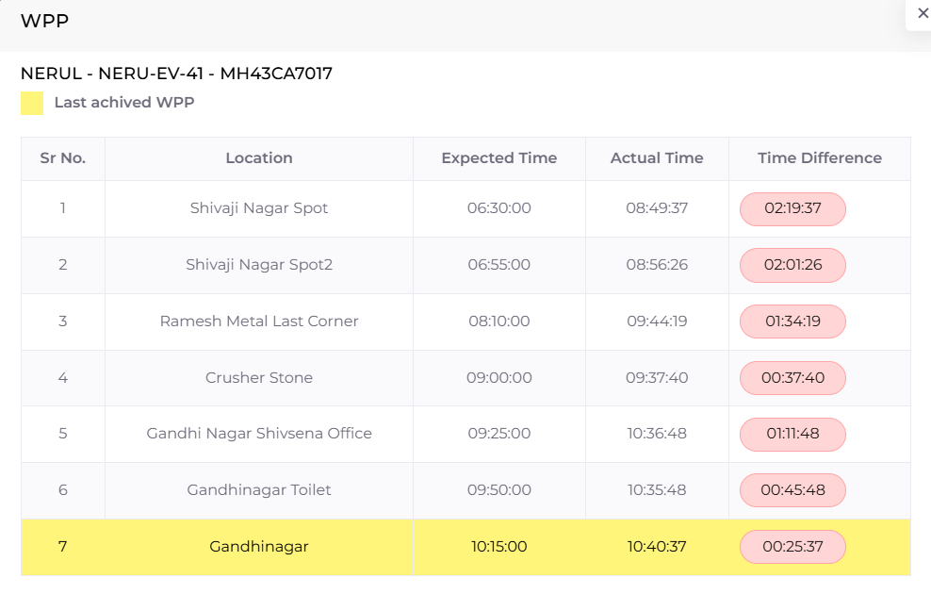
>> we need to provide this functionality in both mobile app for supervisor and admin screen from web.

2) Checkpoint arrival report: -
1}Add Reason, View Photo Column.
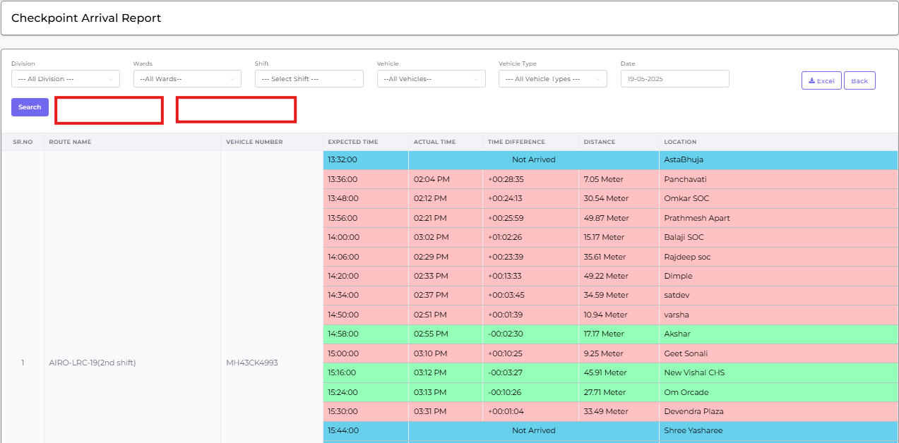
Add
>> same part as previous issue

3)Route Performance report: -
1} Add Route number wise Distance KM column
2}Add vehicle Working Hours per route
3) add work end time for vehicle
>> Add colummn to show total KM travel for route, add total working hours, add last working time stamp for the route
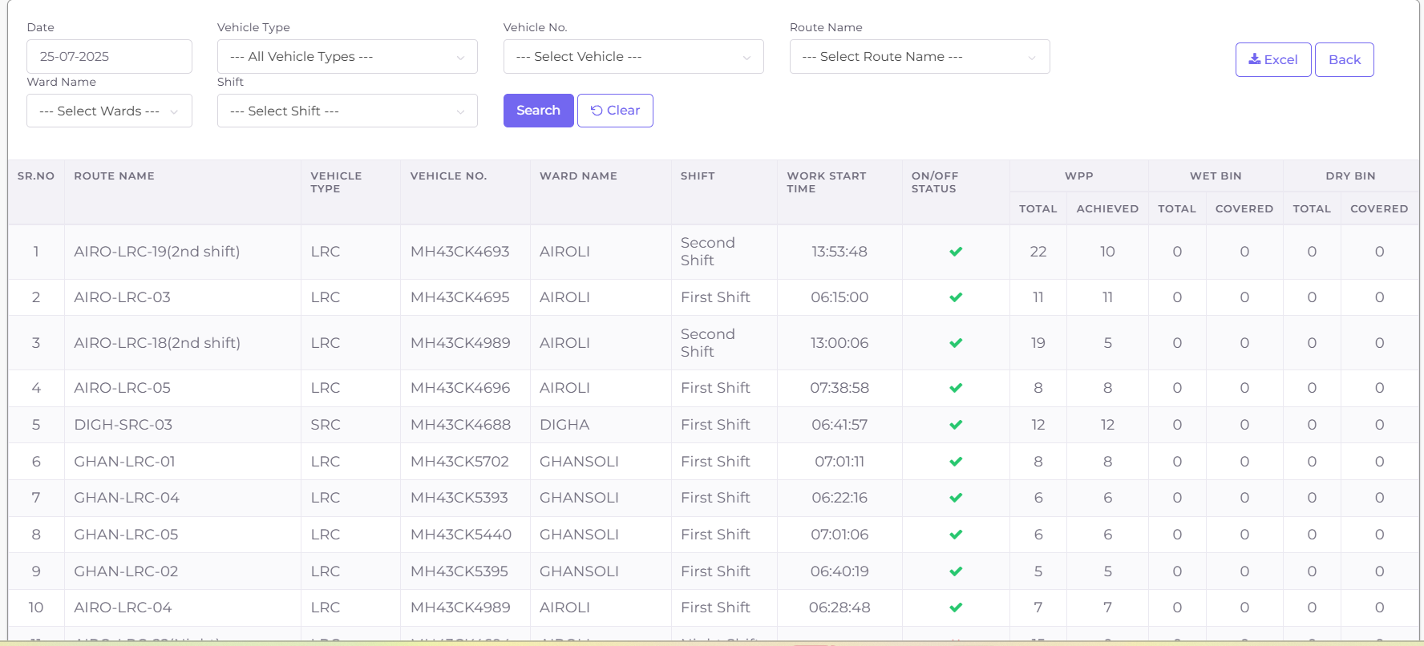

4)Pocket In & Out Time Report: - Vehicle number, Route Number, Pocket IN time, Pocket OUT time.
SR NO. | Division | Ward | Vehicle Number | Route Number | Pocket In Time | Pocket Out Time
1.
2.
3.
We need new report in which, need date filter, vehicle number selection and show which if first geofance entry for route and last geofence out for the route, add another column as vehicle type
5) Stoppage report: - Ward, Vehicle number, Stoppage time, above 15 min Exist WPP.
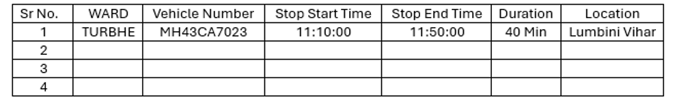
Stop Alert. New report From the parking exit and apart from wpp if it stops for 10 minutes then add in alert, location with hyper link to open map in new window.
6) Add time in Dumping Ground Visit Report.
SR NO. | VEHICLE NUMBER | Vehicle Type | TIME | NO OF VISITS
1
2

>>> We need to add in and out time for visit with actual time the vehicle was there, modify in existing report
7) Vehicle Distance report: - Add report Daily, Weekly, Quarterly, Monthly wise, date rage +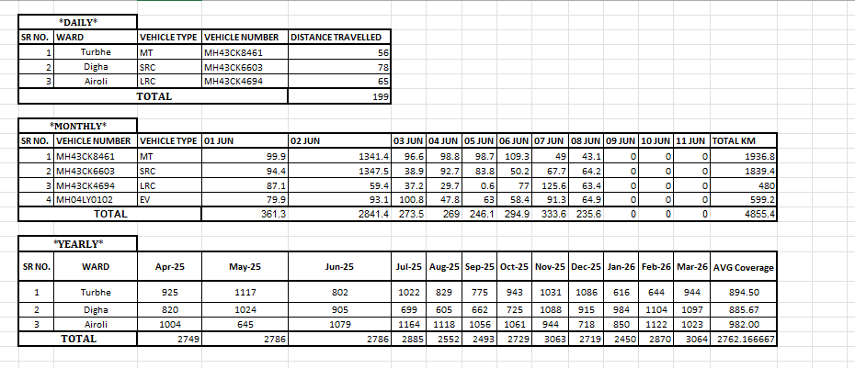
report remain same only we need custom filter as asked.

8) Coverage Report Options -Route wise, Vehicle wise, Ward wise, Zone wise.
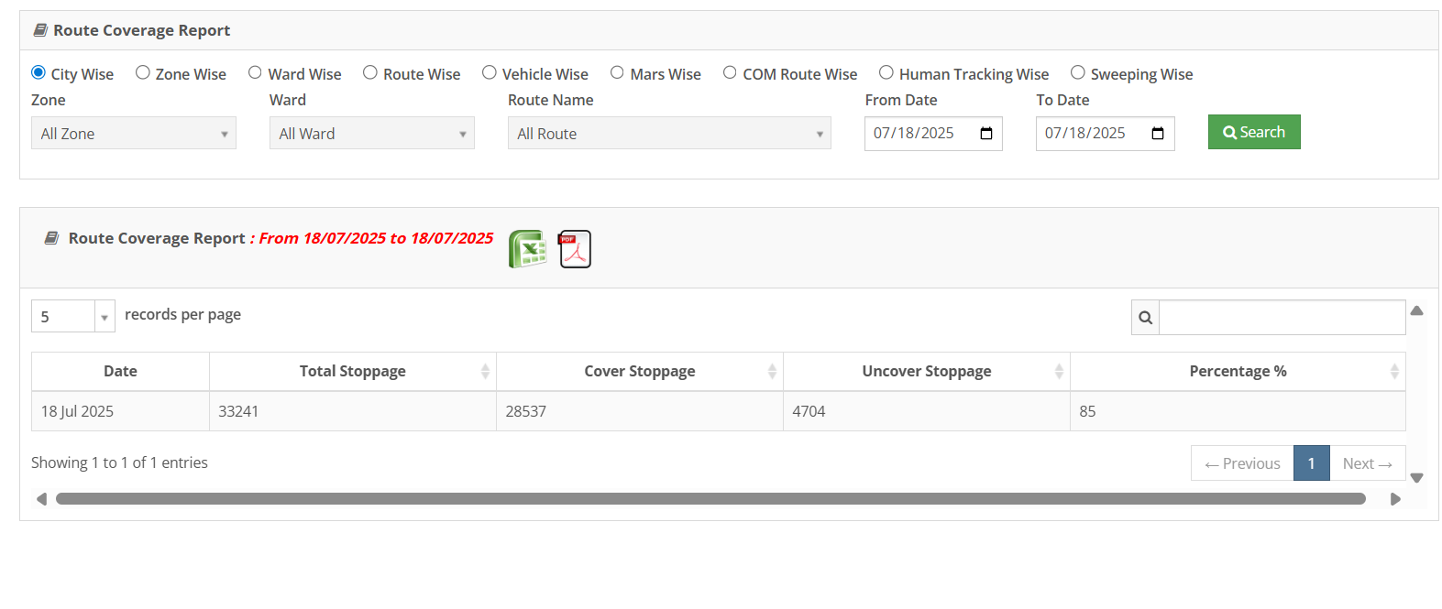
we already have route performance report which is same. We need new report where user can select prminadal wise, ward wise or vhechicle wise...(client will provide screenshot for each recommendations) we will need to generate report and excel in same format.

9) Route coverage Report: - Add report Daily, Weekly, Quarterly, Monthly wise, date rage +
>>> Need to create new report as suggested and show in the screenshot
10) Route Consolidate report: - Sr no, Ward Name, Vehicle Name, Route Name,
Parking Exit Location, Parking Exit Time, Parking in Location, Parking in Time, Route Start Time, Route End Time, Total Stoppage, Cover stoppage, uncover stoppage, Coverage In percentage, Working Hours, Working KM.
Please find the attached for your reference,
Sr  No | Ward Name | Vehicle Name | Route Name | Parking Exit Location | Parking Exit Time | Parking In Location | Parking In Time | Route Start | Route End | Total Stoppage | Cover Stoppage | UnCover Stoppage | Coverage Percentage | Working Hours | Working KM
1 | TURBHE | MH43CK6286 | TURB-LRC-01 | KK PARKING | 6:32 AM | KK PARKING | 1:10 PM | 6:56:00 AM | 12:20:00 PM | 24 | 22 | 2 | 92% | 6 hrs 38 min 0 sec | 32.18

Uncover Stoppage | Coverage Percentage | Working Hours | Working KM
2 | 92% | 6 hrs 38 min 0 sec | 32.18

>>> need new roport with specified columns we need filter as date, ward, division, shift (also add shift column in the report)

11) Vehicle Over speed Notification and Report: - Notification Show on Coverage Dashboard
Vehicle Over Speed Alert Report: - Currently Lat-Long Showing Separately pls combine Hyperlink Lat long.

Client is interested in overspeed and idle vhechicle list. We need thos show details based on the items. Add bell icon on the top right screen to shwo respective list and list all link
SR NO. | WARD | ROUTE NAME | VEHICLE NUMBER | SPEED | TIME | LATLONG/LOCATION
1 | Turbhe | TURBHE-EV-42 | MH43CA7023 | 35 | 12:21:00 | 19.0864216 73.0173916
2
3
4
Note: - Vehicle speed limit is 40 they are cross limit above details automatically show in report.
12) Route Deviation Report: -
Same as Nashik report:- For your reference,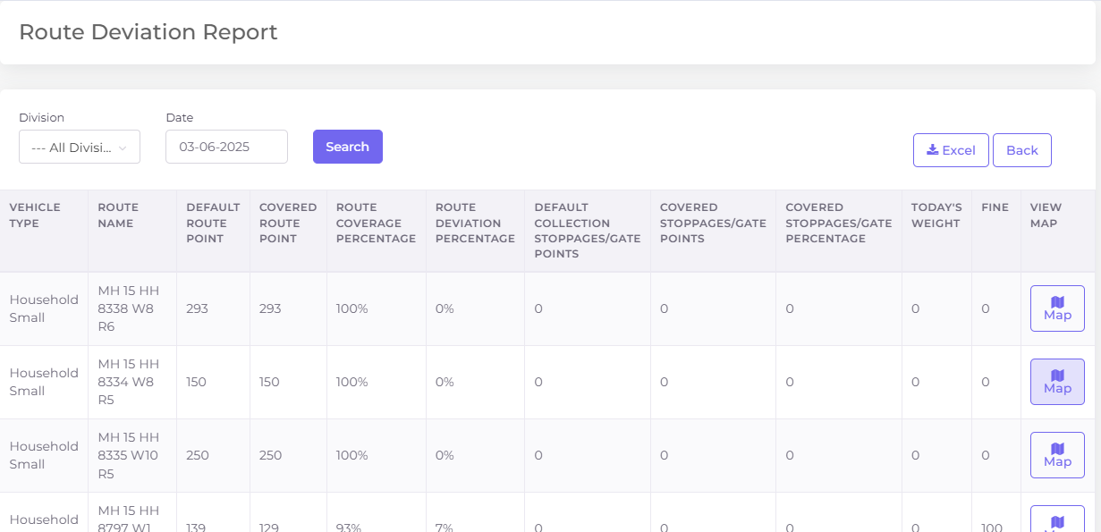
13) Employee Attendance Report: - Add Present/Absent, In/out, weekly off column.
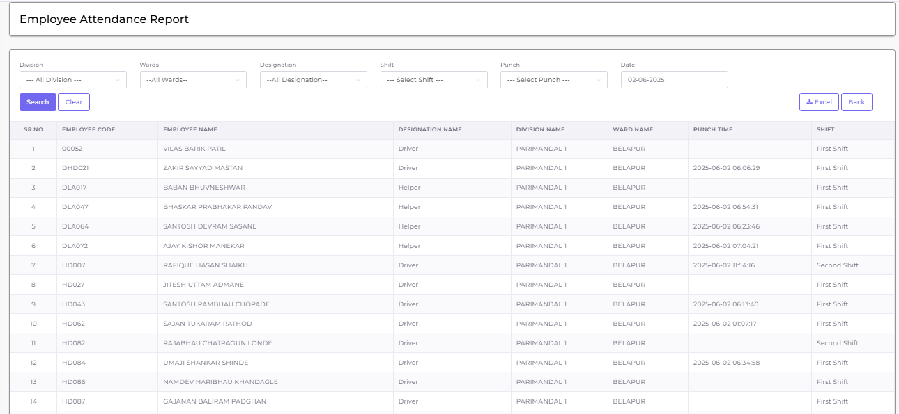
Need to arrange sperate call as there is data differences, Joseph will areange the same with CRM vendor.
14) ICCC Dashboard: - Display List (Tonnage Report)
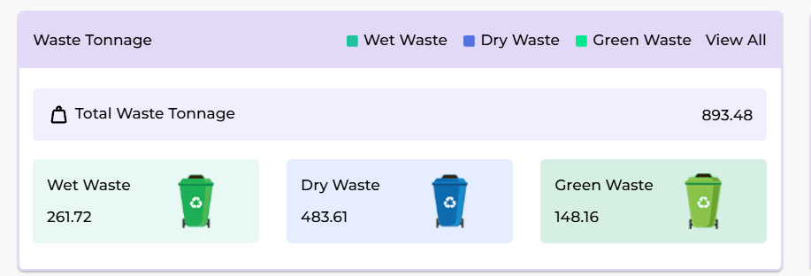
we need to display vehicle wise report based on the the click of garbadge type and display ward name aliong with it.
15) Change Home Page Dashboard to NMMC ICCC Dashboard – shift auto select before 2 first shift after 2 second shift and after 8.3 pm third shift – show ICCC menu for other user as well
>>> after login show always iccc dashboard based on permission. Only show old dashboard if not allowed. Onsider shift change as well based on the current time.
16) Vehicle Timing status section: - Add List & Report below points- add Parking In/Out Time and work end time. https://admin.nmmcswm.com/vehicle_tracking_reports/on_time_and_late_running_vehicles_report
(Sagar will discussed with team and then only we need to check this)
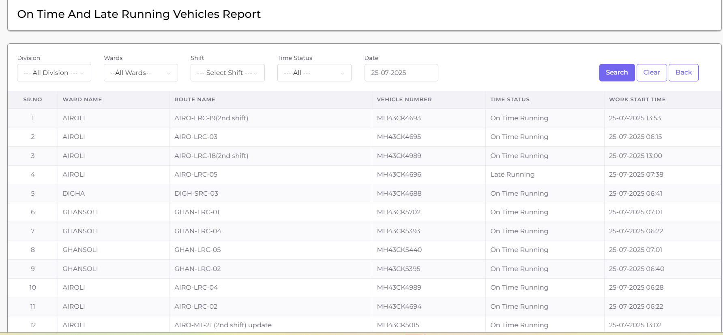
17) ICCC Dashboard: - On Route/Off Route List not available, also add report.
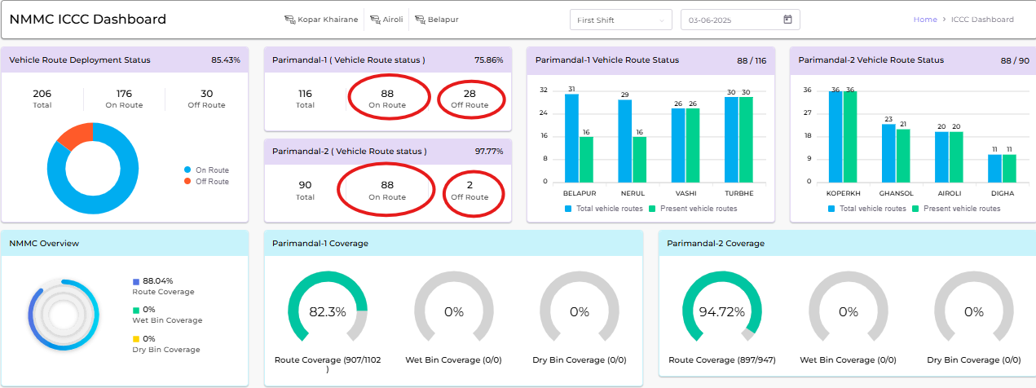
show actual drill down for eah ward. When click on ward show vihicle list on map for selected ward. Then on map show actual route and wpp on map for selected ward.
*REPORT: - count
SR NO. | Division | Ward | Route Name | Vehicle Number | On/Off Status | Time
1 | Parimandal-1 | Turbhe | TURB-MT-24 | MH43CK6135 | On Route | 06:40:30
2 | Parimandal-2 | Digha | DIGH-SRC-03 | MH43CK4688 | Off Route | NA
3
We dont need sperate report , existing performance report should satisfy the requirement
18) OVERALL KM REPORT: - SR NO, PARKING NAME, PARIMANDAL NAME, WARD NAME, VEHICLE NUMBER, VEHICLE TYPE, ROUTE NAME, PARKING TO ROUTE FIRST WPP DURATION (KM), LAST WPP TO DUMPING POINT DISTANCE (KM), POCKET ROUTE LENGTH (KM), DUMPING TO PARKING LENTH, TOTAL WORKING KM, TOTAL WORKING TIME, ACTUAL TONNAGE, DUMPING LOCATION TIME.
SR NO. | PARKING NAME | PARIMANDAL NAME | WARD NAME | VEHICLE NUMBER
1
2
3
4
5
6

VEHICLE TYPE | ROUTE NAME | PARKING TO ROUTE FIRST WPP DURATION (KM) | LAST WPP TO DUMPING POINT DISTANCE (KM) | POCKET ROUTE LENGTH (KM)

DUMPING TO PARKING LENTH | TOTAL WORKING KM | TOTAL WORKING TIME | ACTUAL TONNAGE | DUMPING LOCATION TIME

Sagar will discussed and let us know about it
19. Vehicle GPS active & disconnected (division, ward, vehicle number, vehicle type, Status (GPS active & disconnected).
SR NO. | Division | Ward | Vehicle Number | Vehicle Type | Status
1 | Parimandal-1 | Turbhe | MH43CK0102 | LRC | GPS active
2 | Parimandal-2 | Digha | MH43CK0102 | LRC | GPS Disconnected
3

Create new report show all records as connected disconnect with gps device
20. Stand vehicle in parking Alert & details (vehicle number, type, time).
Dont need to work
21. Add vehicle status on coverage dashboard- Running, Waiting, Idle, GPS Disconnected.
- Running = Speed > 1 and ignition ON
- Waiting = Speed = 0 and ignition ON
- Idle = Speed = 0 and ignition OFF
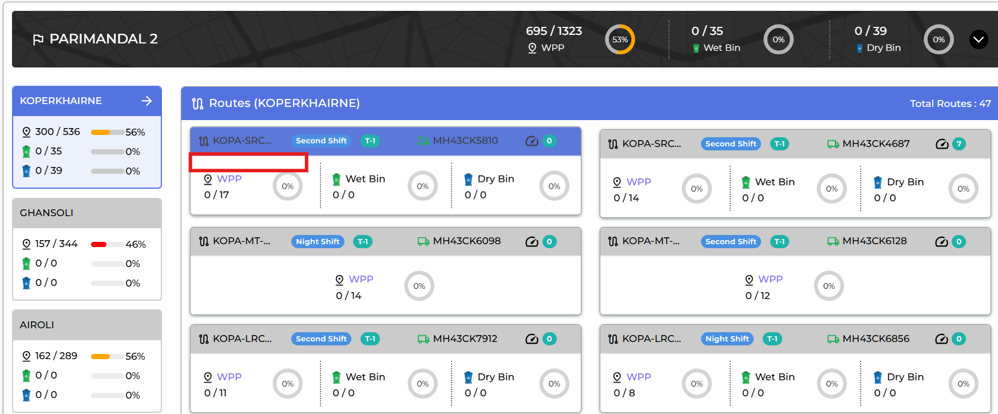
>>> need to show actual wording in the screen instead of mouse over also need time duration like stop since last 10 minutes etc, disconnect, gps disconnect etc events also considered
22. Change Below card to Graphs.

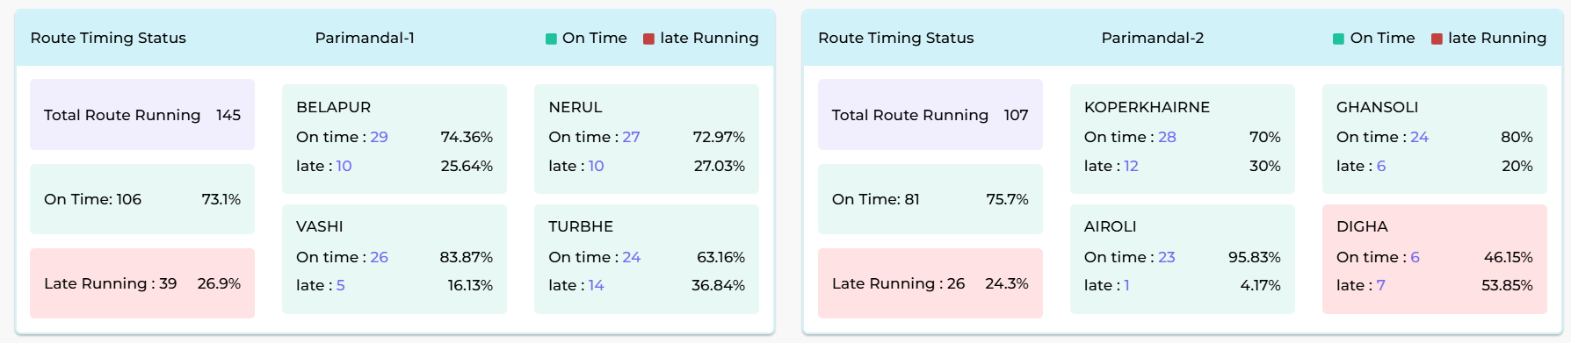
Refer the PPT for the obeservation 7

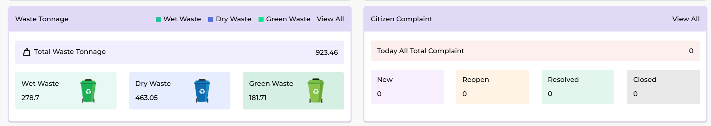

23. Change Bar Color as a Line chart (It’s Look All Blue).

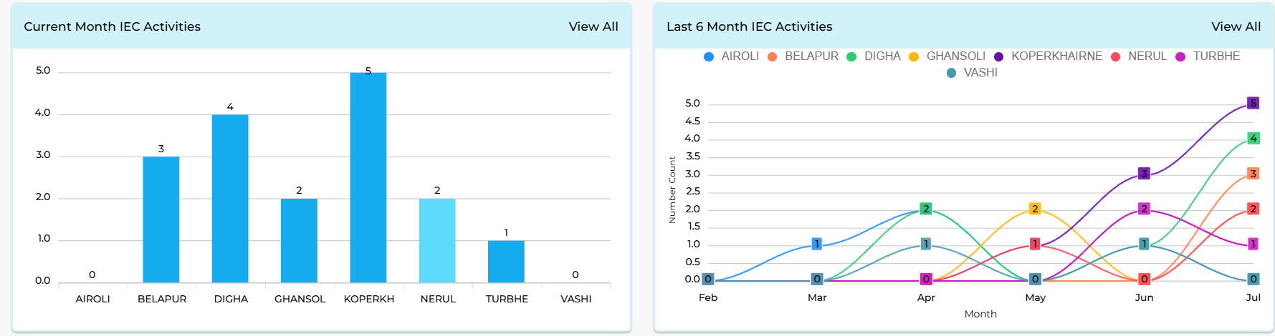
Refer to observation 9 from the ppt

24) Vehicle Running History: - Coverage Dashboard
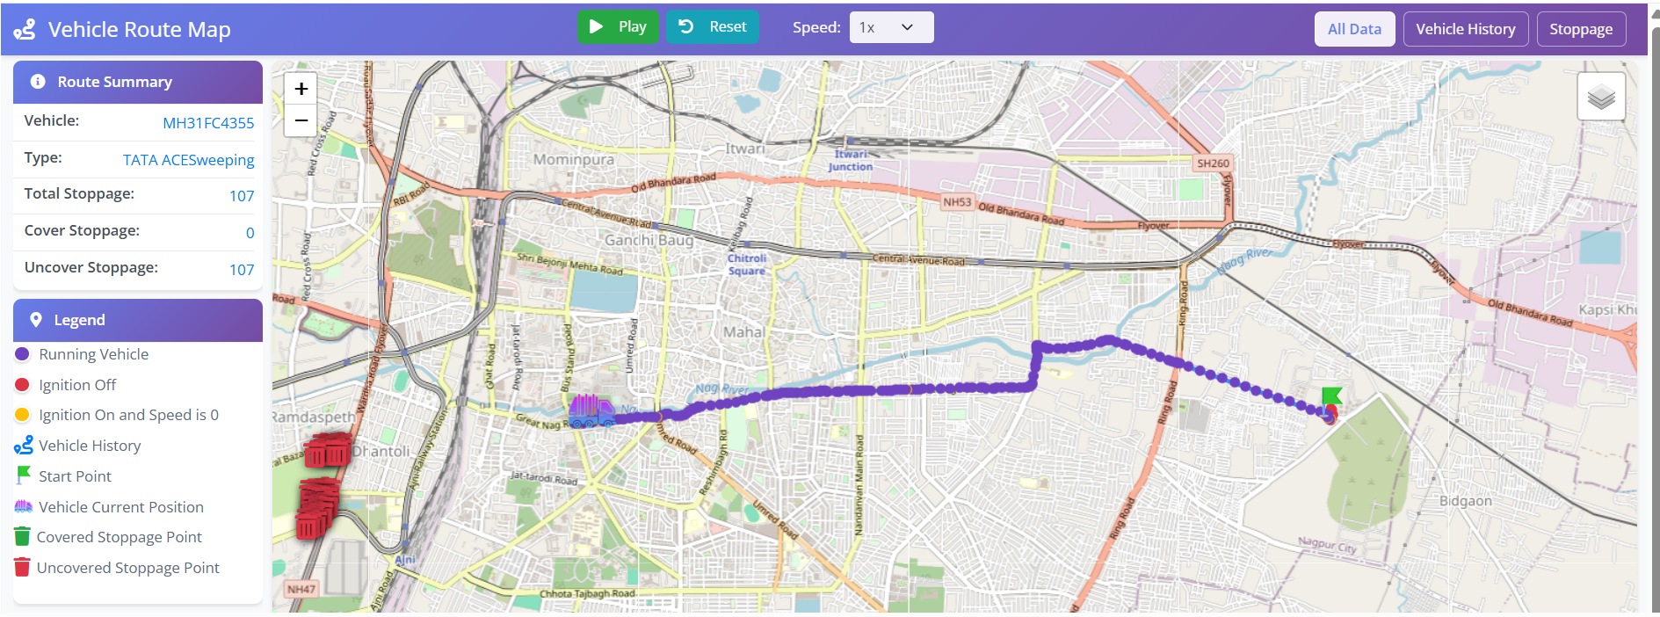
Add play button to show the vhicle history on the map need to discussed again
25) Show All Routes: - When we Click on route Hide Route on Map.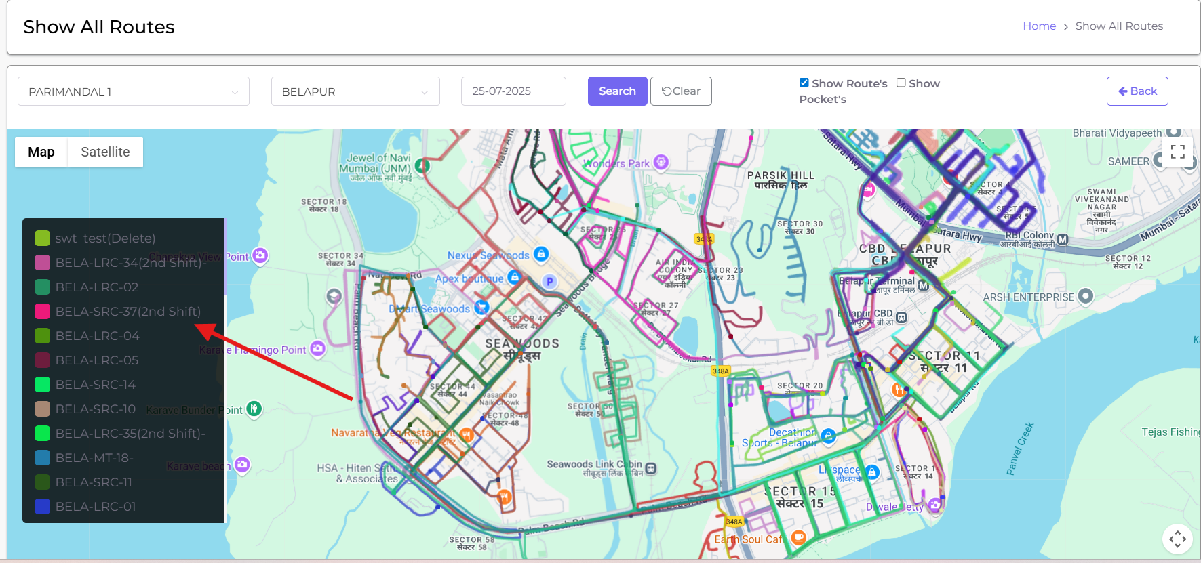
show checkbox and only highlight the selected route and so only specific division need to select

26) Route Hourly Coverage:- Add Zone Wise Details on ICCC Dashboard.

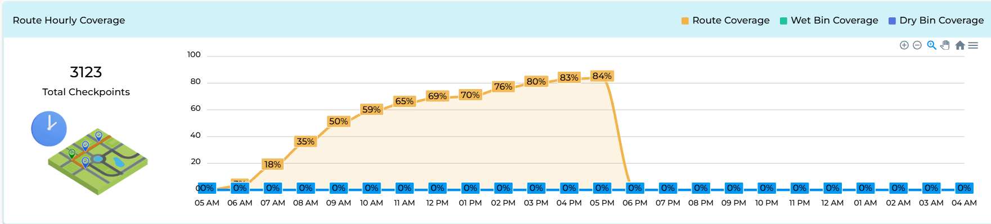
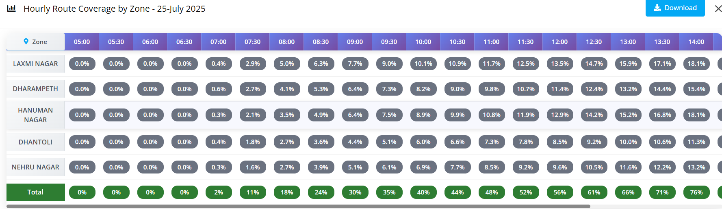
Refer observation 5 from ppt, on click of each number drilldown to parimandal, wards an d after ward each route and it shold work independantly for checkpints, wet beans and dryh bins
27) Add Toll free Number on ICCC But do not active.
Add tollfree number and don’t display for now as joseph said, add in the bottom side, don’t work for now
28) All Graphs Transformation Option(Line Chart, Pie Chart, Bar Chart, Column Chart) on ICCC Dashboard.
Only for possible charts its possible, allow user to toggle between line chart and bar chart. When user make these changes save them as cookies and display same for next visit.
29) Change Colors Graphs & Visuals.
Same as above
******************************************************************************************
*SOFTWARE IMPLEMENTS FROM KPMG TEAM*
1. Reporting Improvements
- Provide custom date filter options (Weekly, Monthly, Custom Range) for all reports.
2. Reports with Missing Data
The following reports currently do not display any data:
- Vehicle Type Wise Present and Absent Vehicle Report.

4. SMS integration for citizen complaints.
5.My additional points as below
- DMC suggested dashboard visuals
- Drop down should available left side under main menu.
- Attractive colours in IEC and other tab
- List should available once we click each tab
- Citizen app for raising complaints
- SMS based complaint system
- Monitoring logs, active time, idle time and auto logout after 15 min idle time, expect ICCC login.
- Reports- vehicle stand more than 10 min out of geofence, also alert list required for waiting time in geofence.
6. Citizen complaint application development (need platform).
7. If i click on any graph need to show details. it applies for all bars and pie charts available on ICCC. 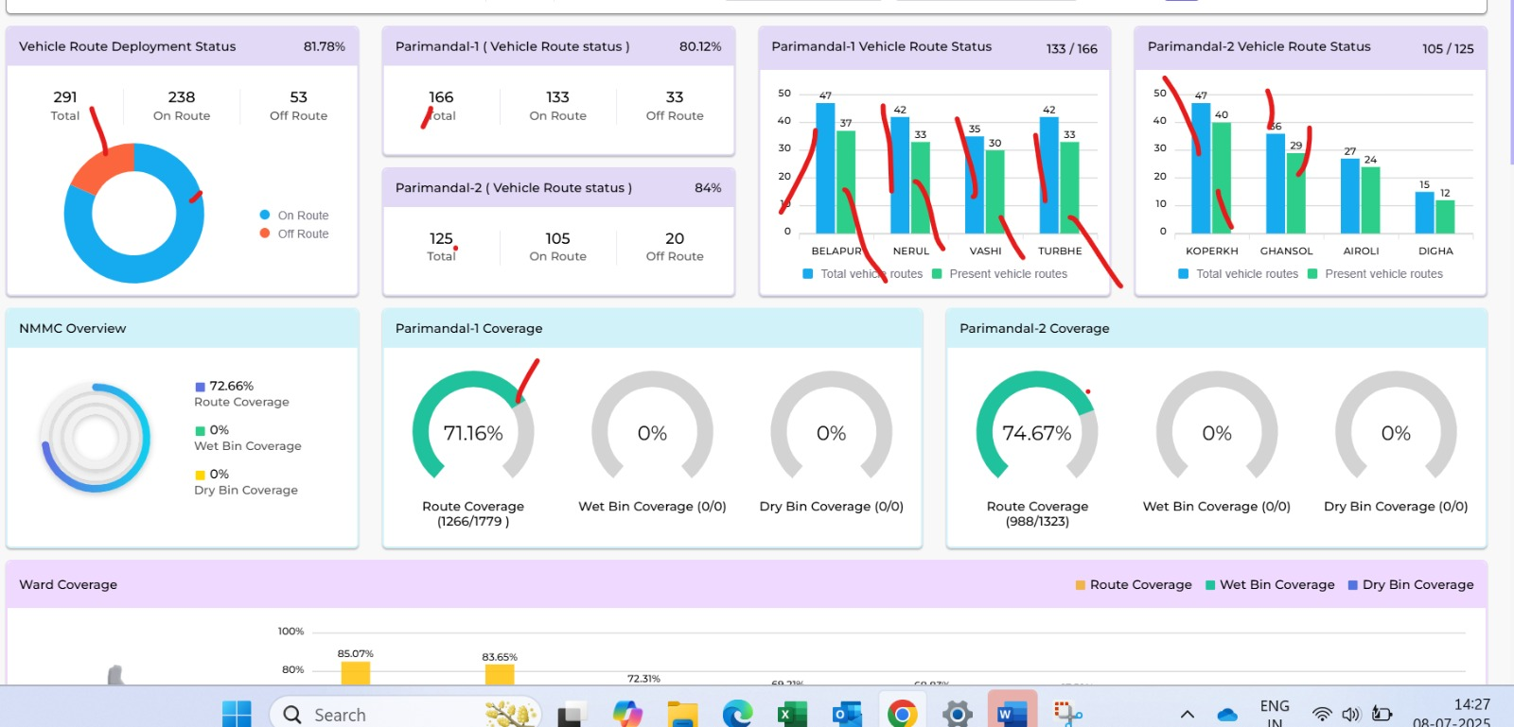

THANK YOU

PPT points from 30 in excel
30. Real Time Map- Observation 1
>> need to show stopped vhiecle in the real time map check observation 1 from ppt
31. ICCC Dashboard - Vehicle Deployment - Observation 2
>> Refer observation 2

