13) Employee Attendance Report
- need API

14) ICCC Dashboard: - Display List (Tonnage Report)
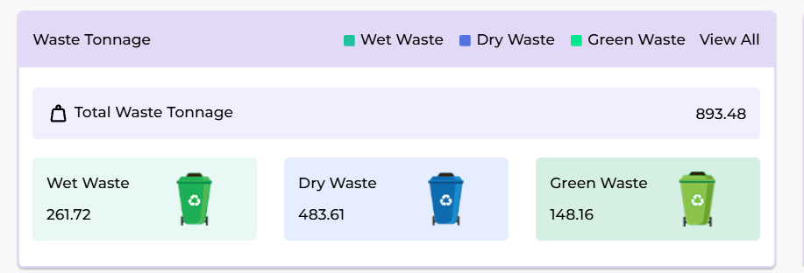

we need to display vehicle wise report based on the the click of garbadge type and display ward name aliong with it.

17) ICCC Dashboard: - On Route/Off Route List not available, also add report.
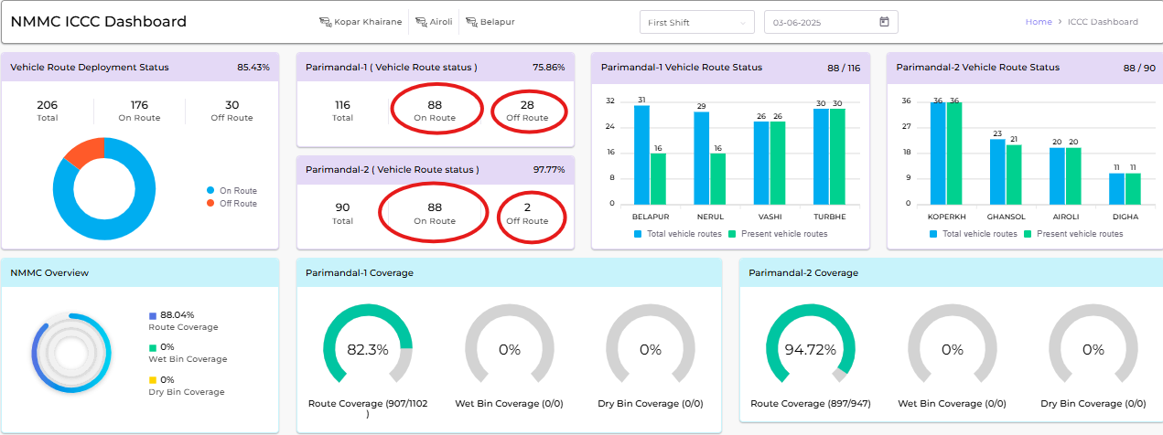
*REPORT: -
on click of each count we will open the popup box it will show the list of route (on/Off) with vehice number, time and status(onroute or offroute).

29) Change Colors Graphs & Visuals.
We will update all colors as per ppt for chart

30. Real Time Map- Observation 1
- vehicles in parking will whose ignition is off will be in orange
- vehicle on route whose ignition is off and speed is 0 for more than 60 minutes will be red
- Add above to legend

31. ICCC Dashboard - Vehicle Deployment - Observation 2
Not understood what needs to be done.

32. ICCC Dashboard - Zone Coverage Card - Observation 3
- legend and color matching
- other map view is not clear

33. ICCC Dashboard - Ward Coverage Graph - Observation 4
- ward coverage bar, we will add click event of each bar on click will show details of that bar only. Remove mousover event.
- on bar click we will show all routes of selected ward with information like route name, vehicle assigned, total wpp , achived wpp. In case of bin clicked show route name, vehicle assigned, total bins and achieved bins.

34. ICCC Dashboard - Route Hourly Card-Ward wise Coverage - Observation 5
- when click on route coverage percent we will show ward wise breakdown of total achived percentage and then once clicked on ward we will show list of routes with route name, vehicle number, ward , total wpp achived till selected hour for selected ward. Same will be shown when click on wet bins and dry bins.
- on click of WPP or bin number we will show wpp details like name, expected time and achived time.

35. ICCC Dashboard - Dumping Graph- Drilldown - Observation 6
- Need data in API

36. ICCC Dashboard - Route Timing Status Card - Observation 7
- change fonts and color code as per instructions
- show “ontime / out of” vehicle numbers

37. ICCC Dashboard - Waste Tonnage Card - Observation 8
- show vehicle number , weight and time when clicked on respective icon

38. ICCC Dashboard - IEC Activity - Observation 9
- already working as expected. Dont know what to change

Add drop-down on left naviagtion for icc dashboad, coverage dashboard and reports, so that user an directly select the required taget – Priority.

Estimate detils
Detils
Total estimated days | 25 Days

We will provide updates by every week for the completed task.

