CTS Feedback_21-08-2025
- where is question 1. Implementation Year of PG - (Dropdown option - Year 1, Year 2, Year 3 & Graduate). Also keep the question sequence as given by us, PG name reflecting two times keep that only once
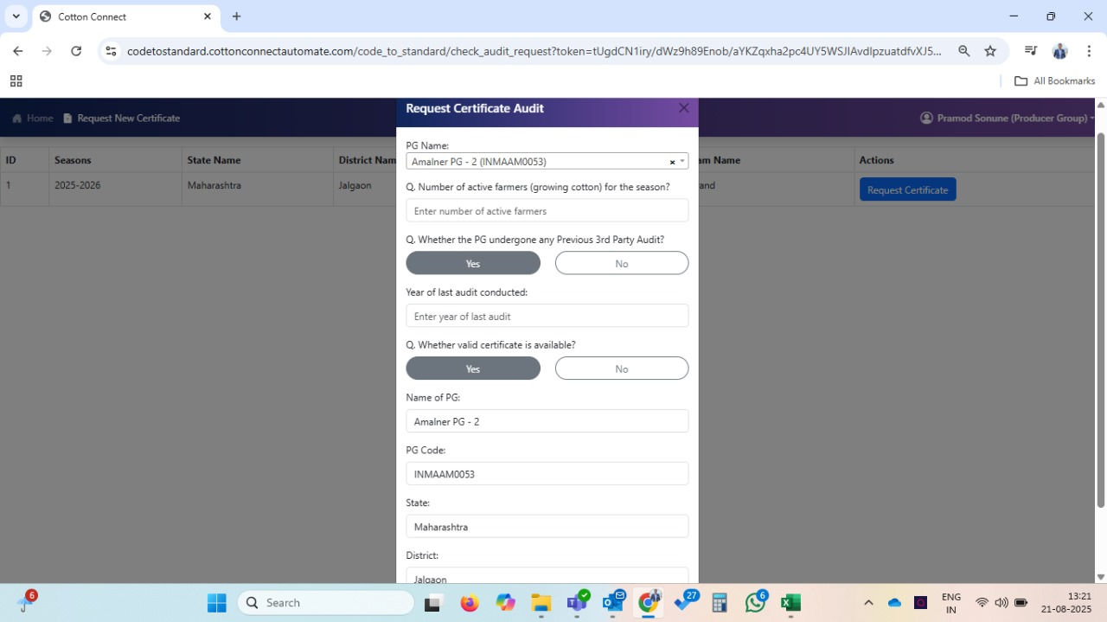

- why this question appearing at CC farm level, it should appear only at CC verification
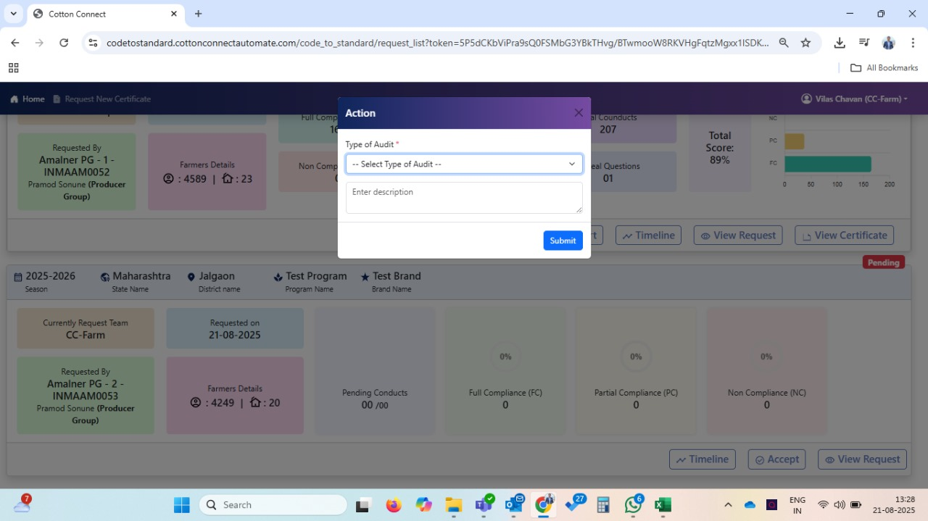

- On view request it’s still showing old info, it need update as per latest questions added at PG
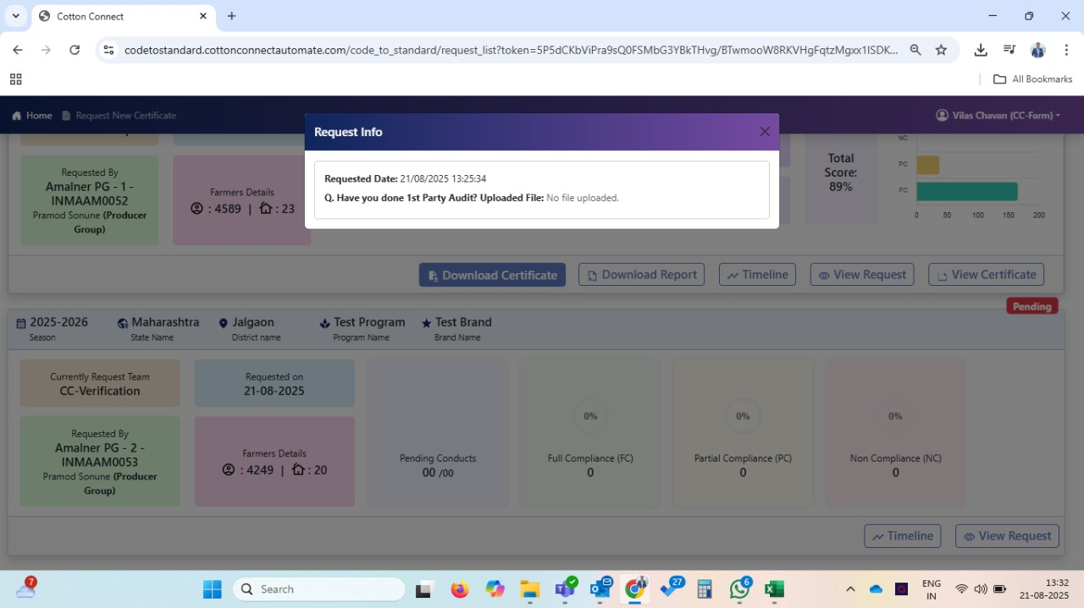
- I am still not able to understand on which question code i have clicked, as discussed earlier highlight clicked questions code tab by user and highlight file uploaded codes tabs (currently its very light green color which is not easily identifiable, please highlight properly as user can identify easily.
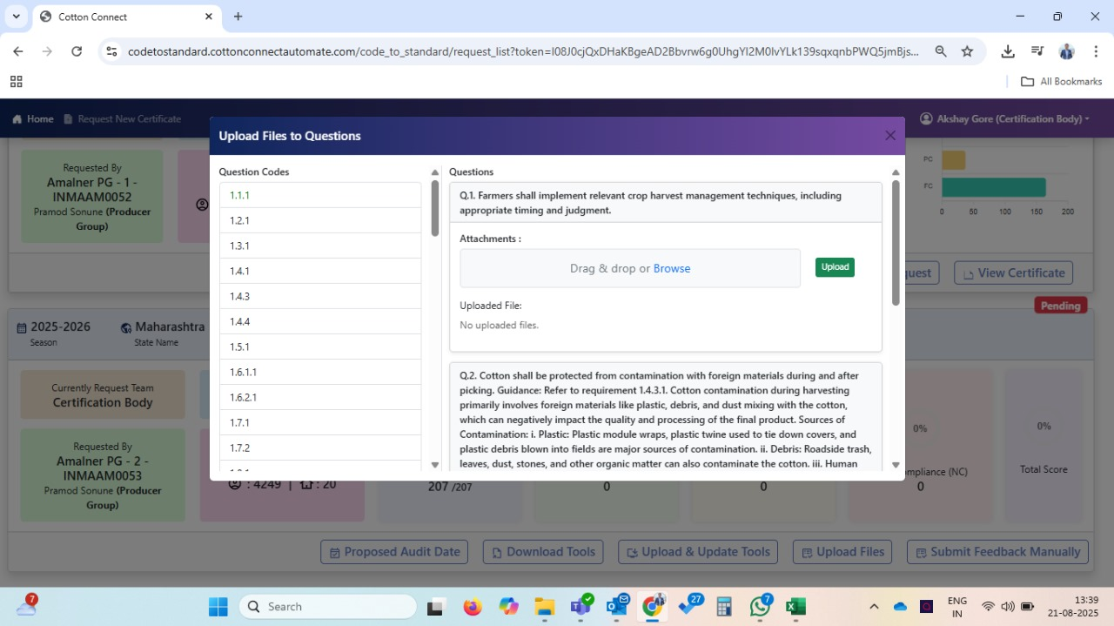

- why this view request tab is seen at CB level, it should not be visible to CB, it’s was done earlier pls avoid such bugs
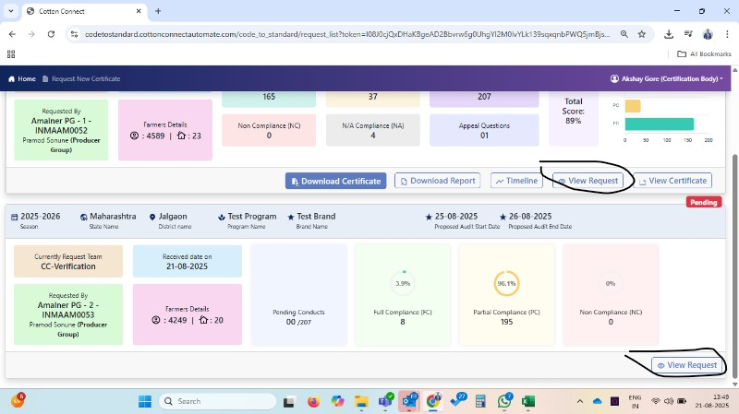
- View request tab need to visible before accept audit request also for CC Farm, CC verification, & Producer Group
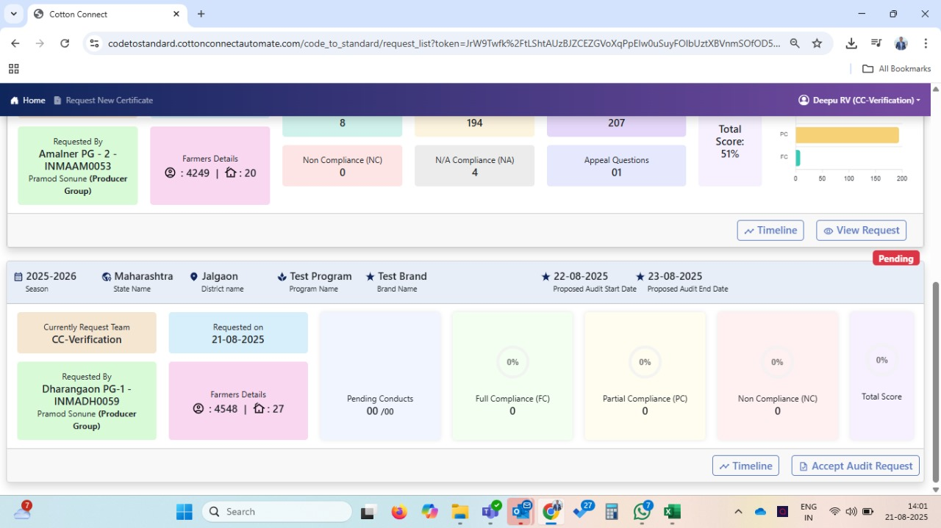

- In case of score less than 60%, no pop up is showing as not eligible for certificate and no option is coming for Actual Audit Start Date and Actual Audit End Date. This popup needs to show
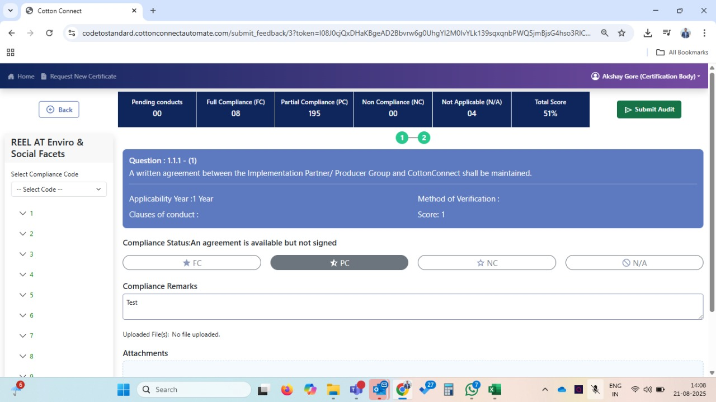
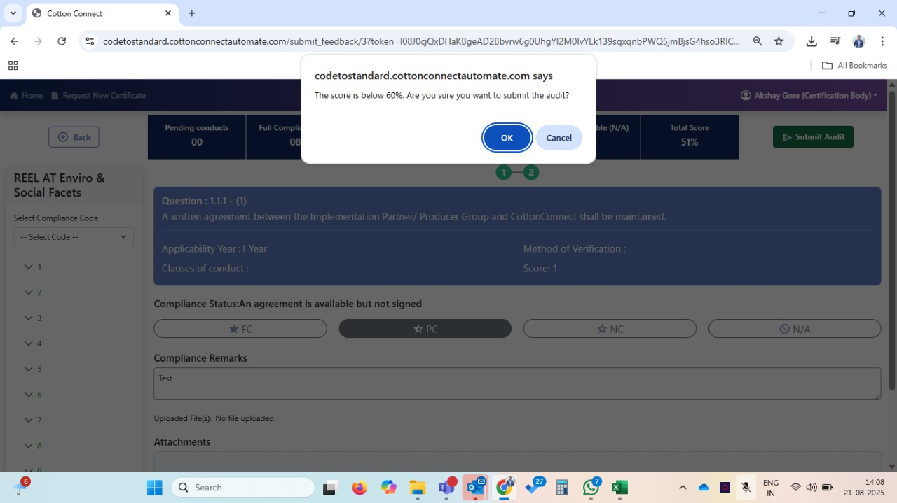

- Where is the CAP upload functionality is developed? I have not seen it in PG level while appeal the questions
- Post sowing list as per shared format not getting downloaded from internal users account (PG, Farm, Verification)

