User Flow: Bhumika Employee Attendance App (Supervisor Panel)
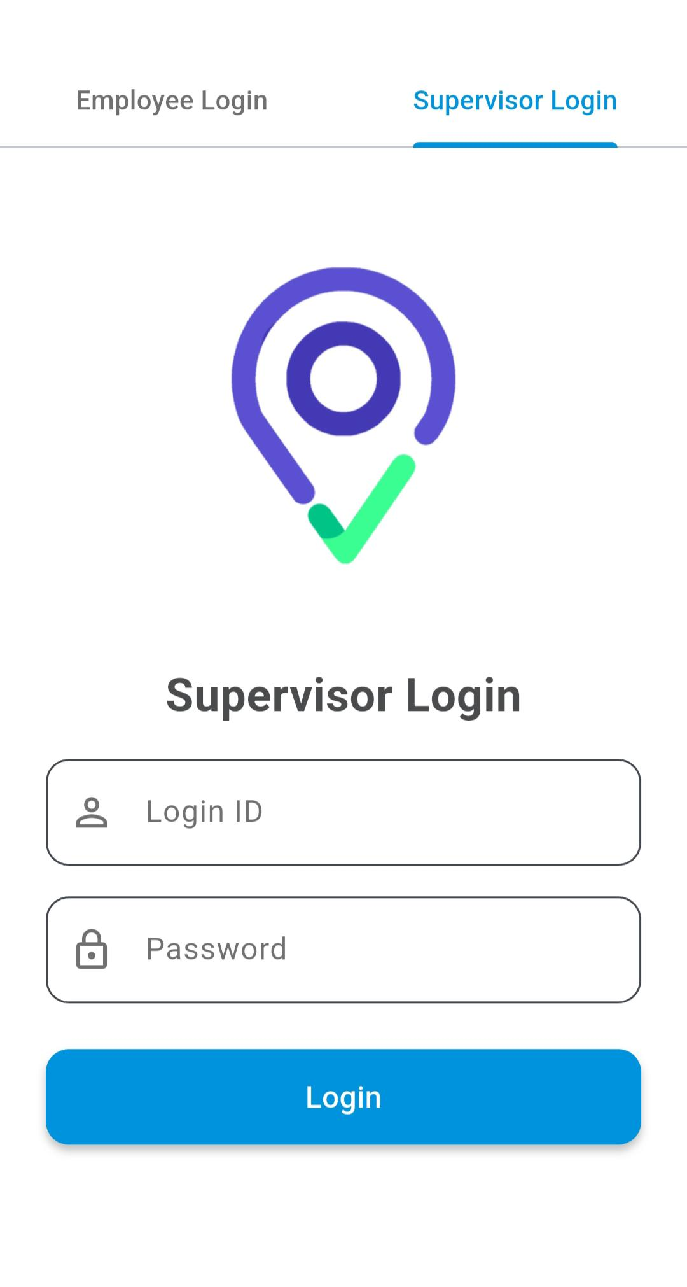

Step 1: Launch App
- Open the application.
- Select “Supervisor Login” tab from the top.

...............................................................................................................................................................................

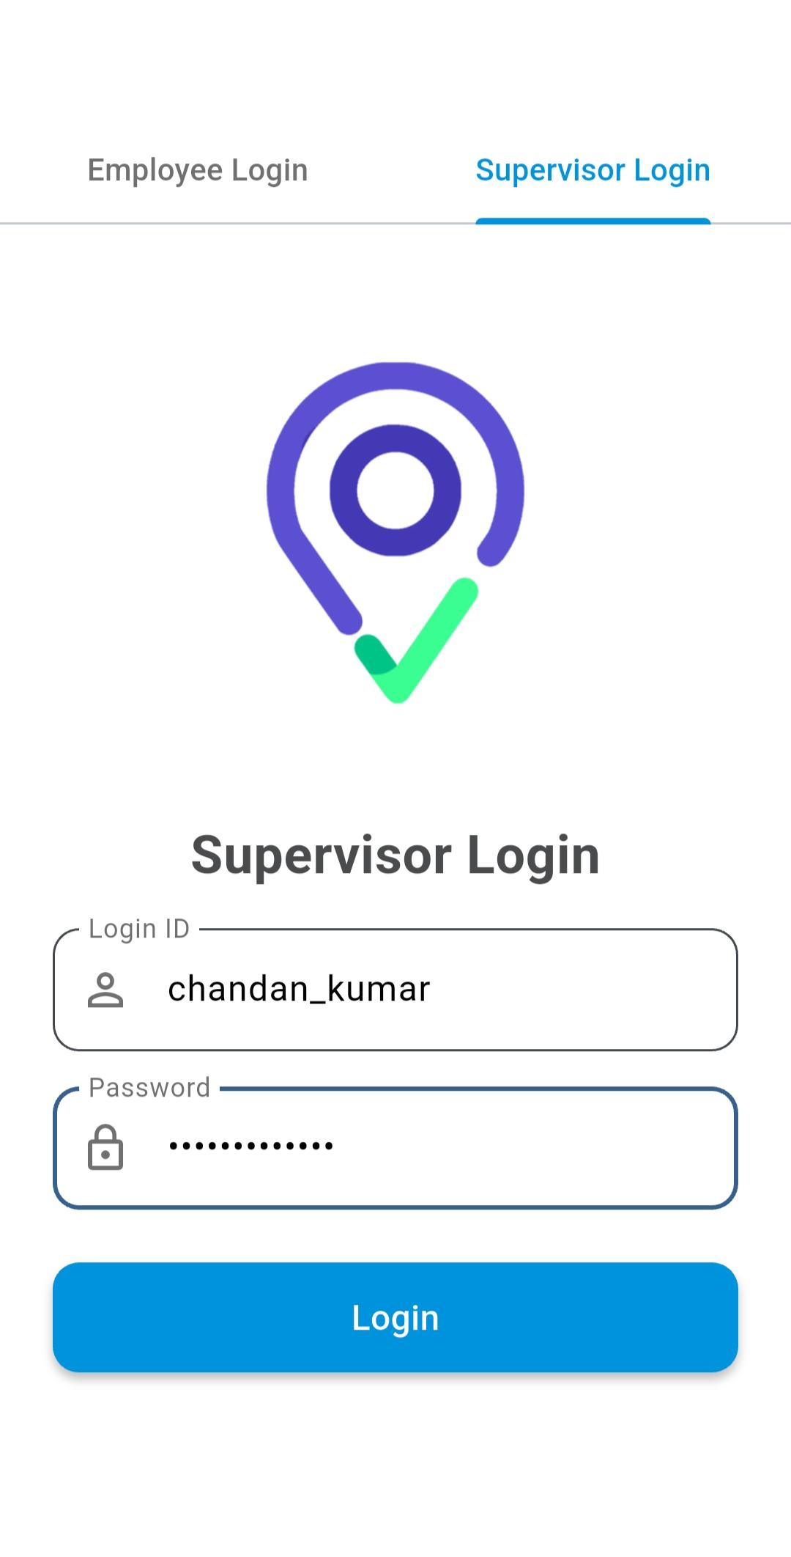

Step 2: Supervisor Login
- Enter Login ID and Password.
- Example: chandan_kumar
- Tap on the “Login” button.

...............................................................................................................................................................................

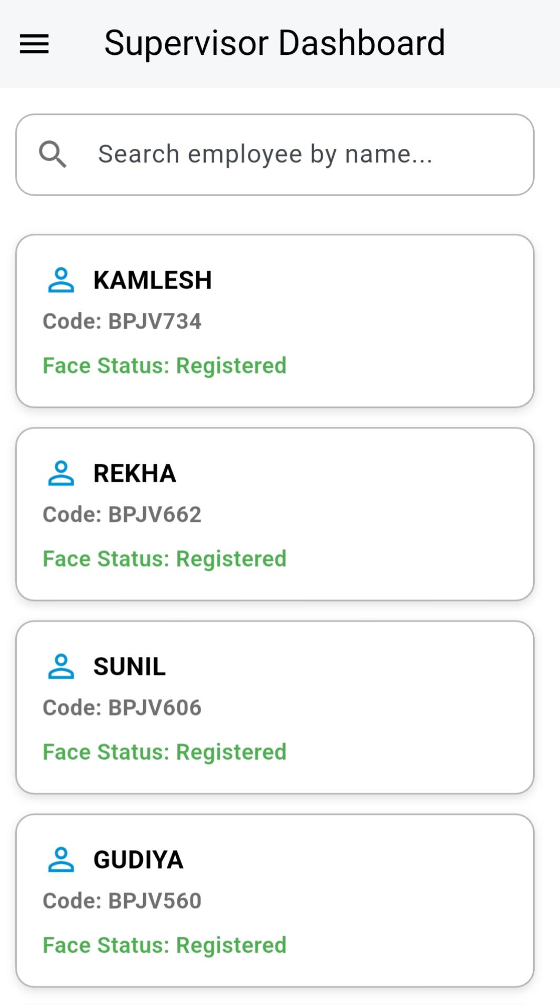

Step 3: Navigate to Supervisor Dashboard
- After successful login, user is redirected to:
  - Supervisor Dashboard screen.
  - A search bar appears on top.

...............................................................................................................................................................................

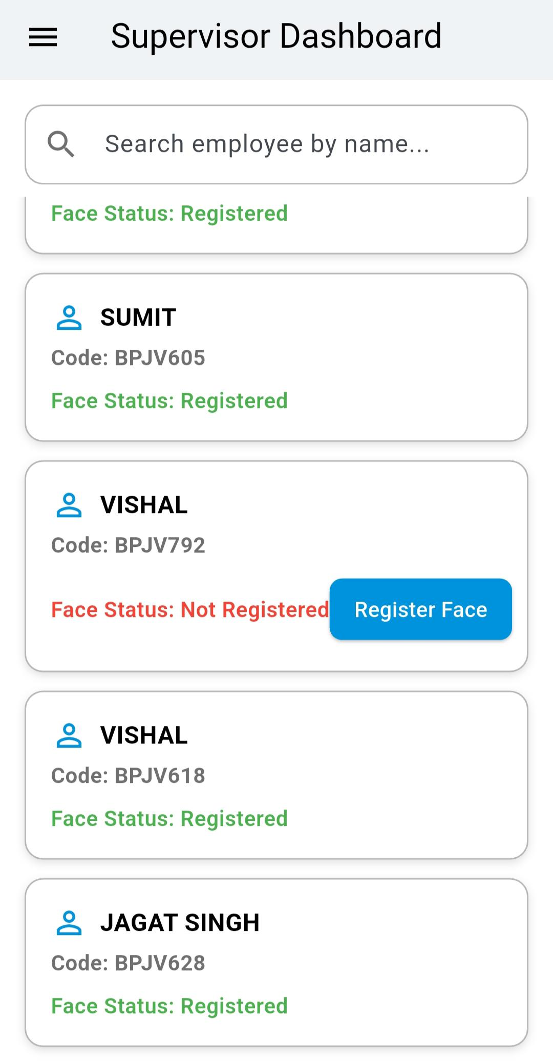
Step 4: View Employee List
- All employees under the supervisor are listed with:
  - Employee Name
  - Employee Code
  - Face Status: Registered / Not Registered

...............................................................................................................................................................................

Step 5: Use Search Functionality
- Use the search bar to filter employees by name.

...............................................................................................................................................................................

Step 6: Face Registration Flow
- If employee's Face Status = Not Registered:
  - Button appears: “Register Face”
  - Click button → Open Selfie Capture → Register face.
- If already registered:
  - Status shows in green: Face Status: Registered
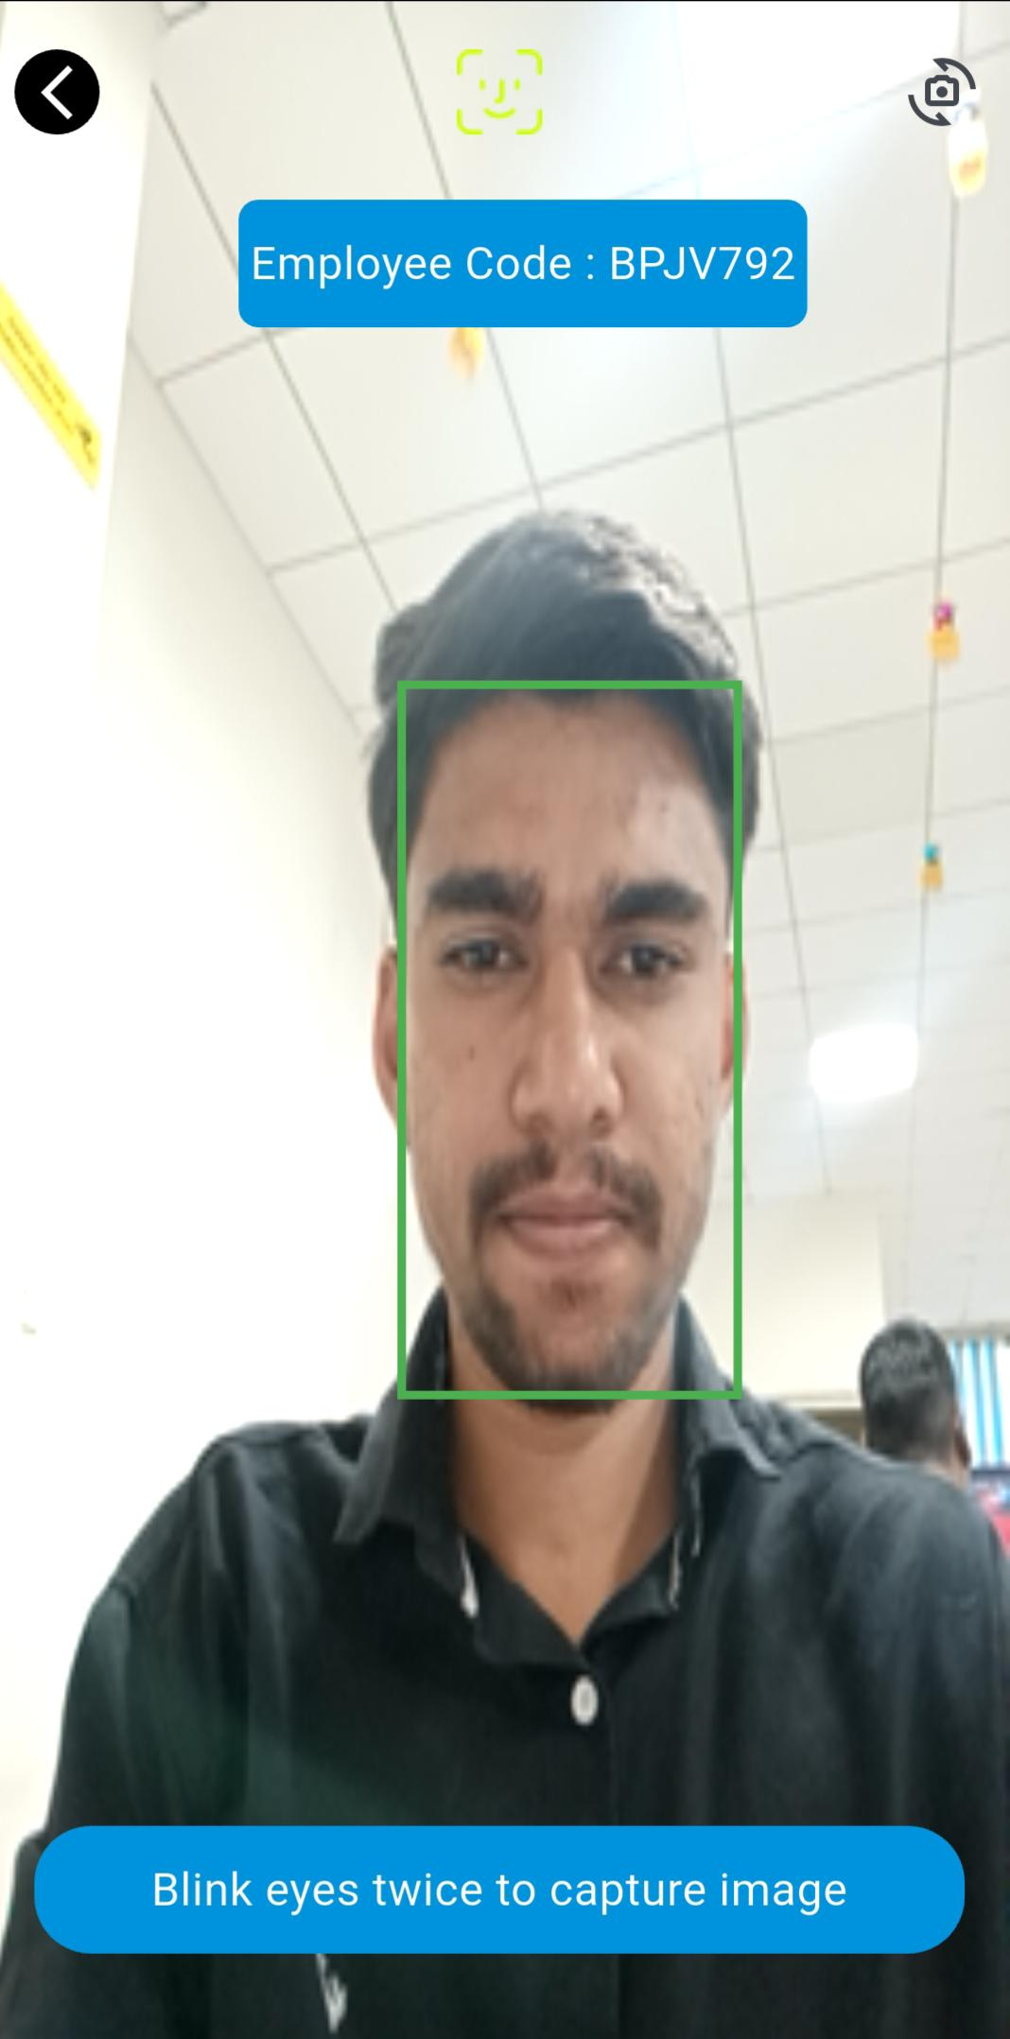
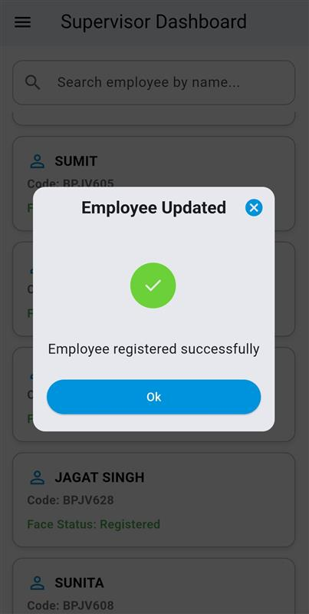

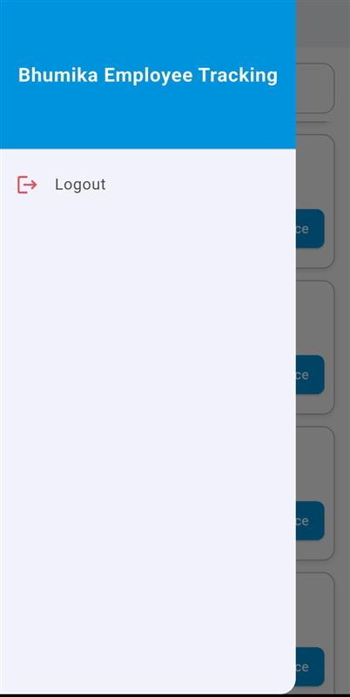

Step 7: Logout
- Tap the hamburger menu (top-left corner).
- Tap Logout to exit session.

...............................................................................................................................................................................

User Flow: Bhumika Employee Attendance App (Employee Panel)

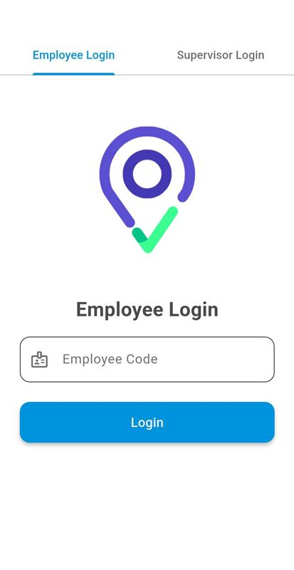

Step 1: Employee Login
- Open the app.
- Select the “Employee Login” tab from the top.

.................................................................................................................................................................................
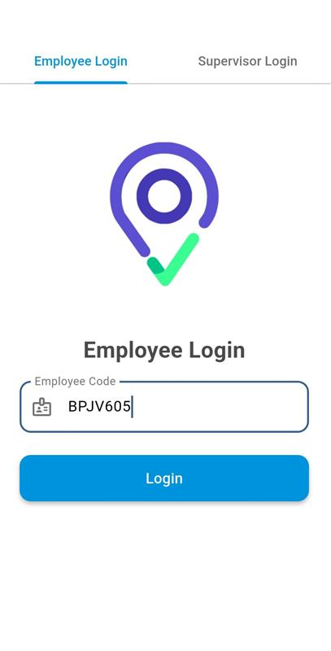

Step 2: Enter Login Code
- Input the Login Code (e.g., BPJV605).
  - This is the Employee ID.

Step 3: Click Login
- Tap on the “Login” button.

...............................................................................................................................................................................

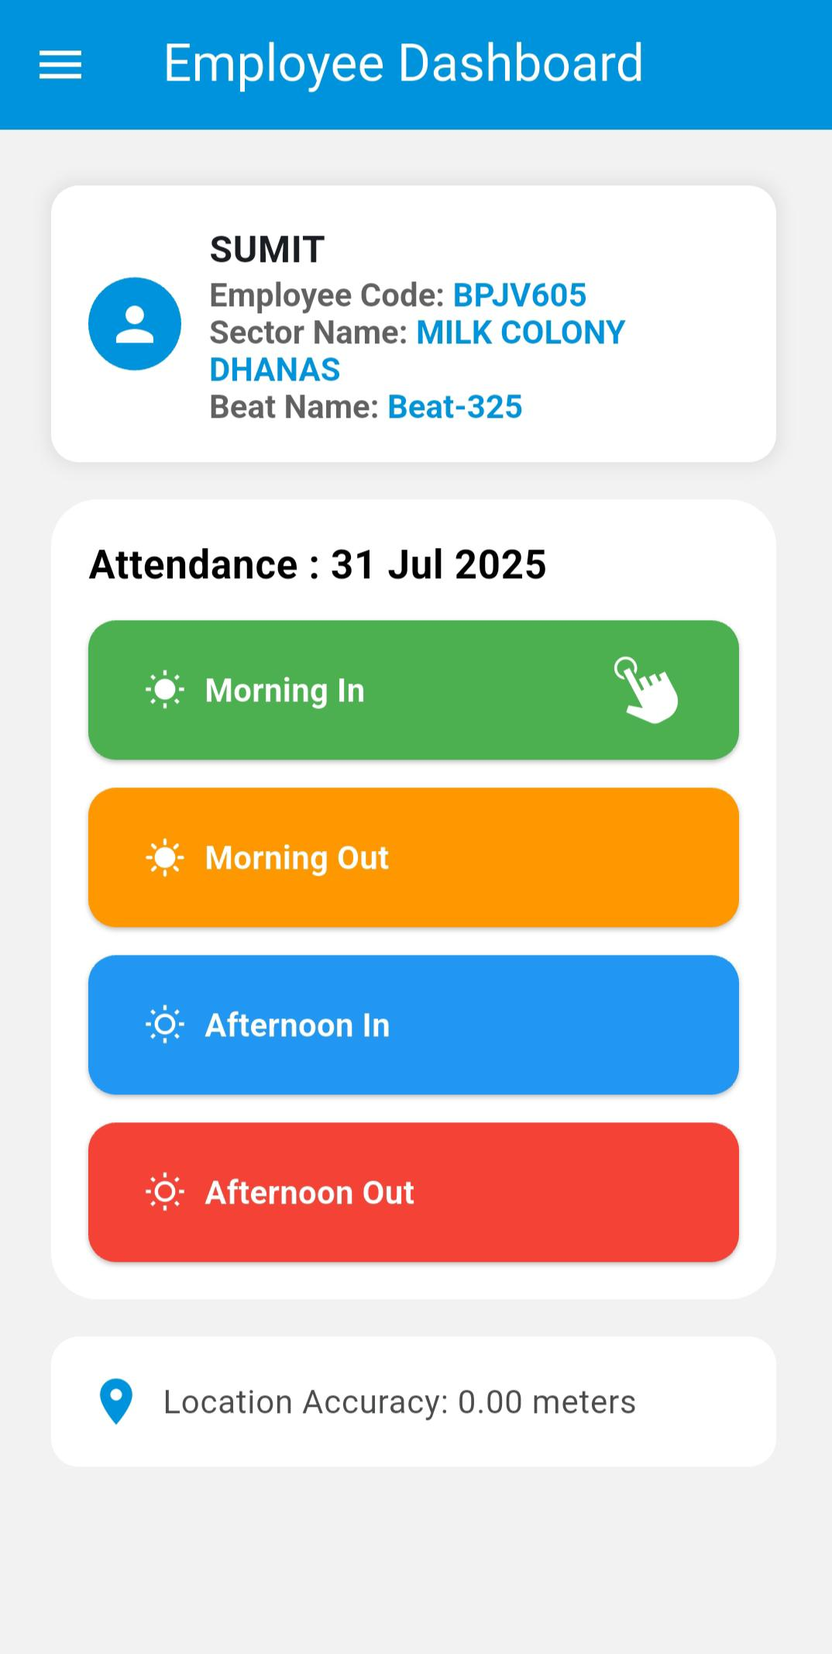

Step 4: Navigate to Employee Dashboard
- After successful login, user is redirected to:
  - Employee Dashboard screen.

.......................................................................................................................................................................................
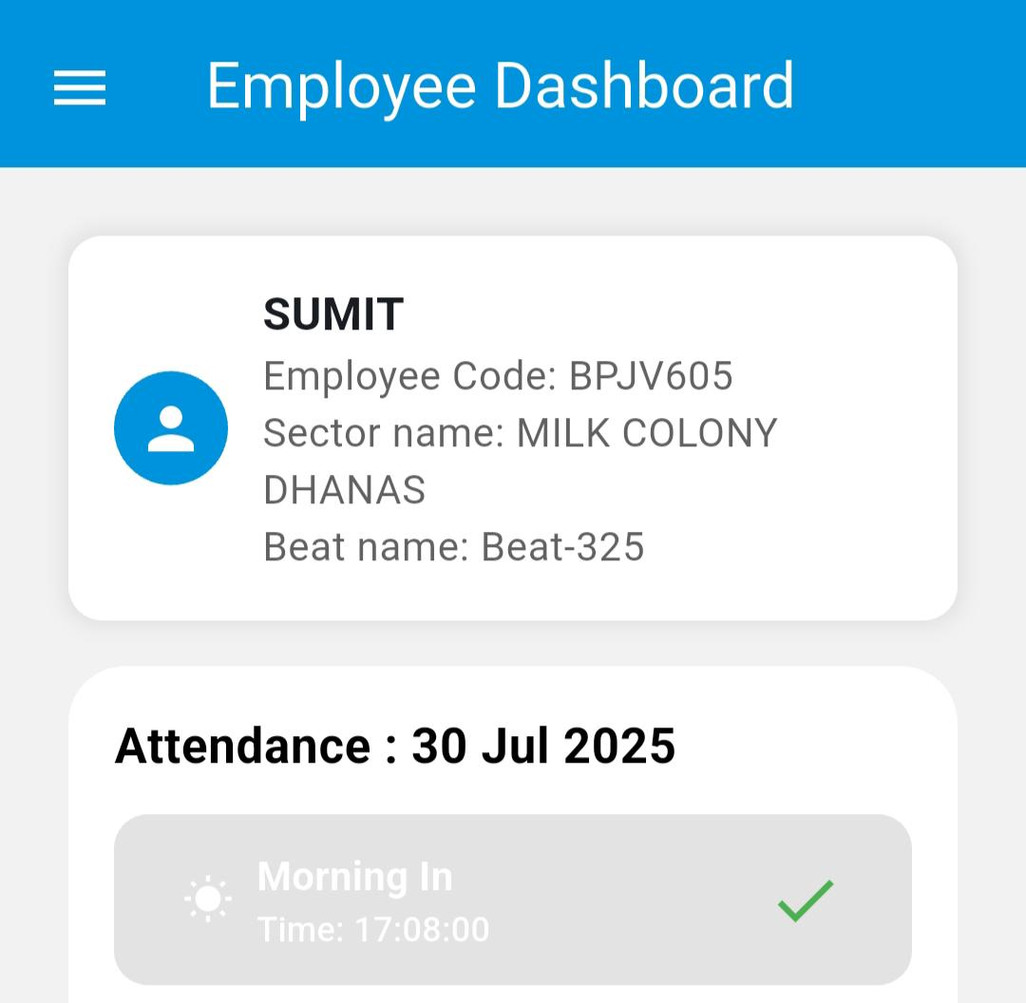

Step 5: Morning IN Attendance
- Tap on “Morning In”.
- The app captures:
  - Actual Morning In Time
  - Face Selfie for verification.
- Face attendance is recorded successfully.

.....................................................................................................................................................................................

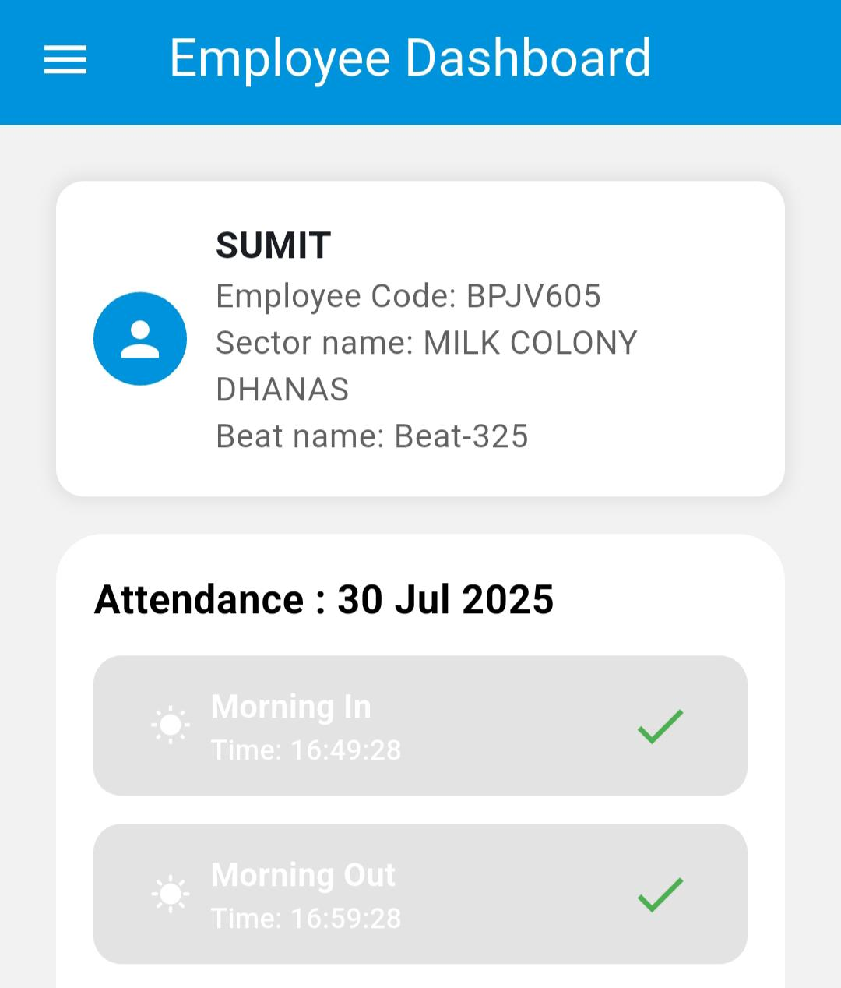

Step 6: Morning OUT Attendance
- Tap on “Morning Out”.
- The system captures:
  - Exact Morning Out Time in the Out section.
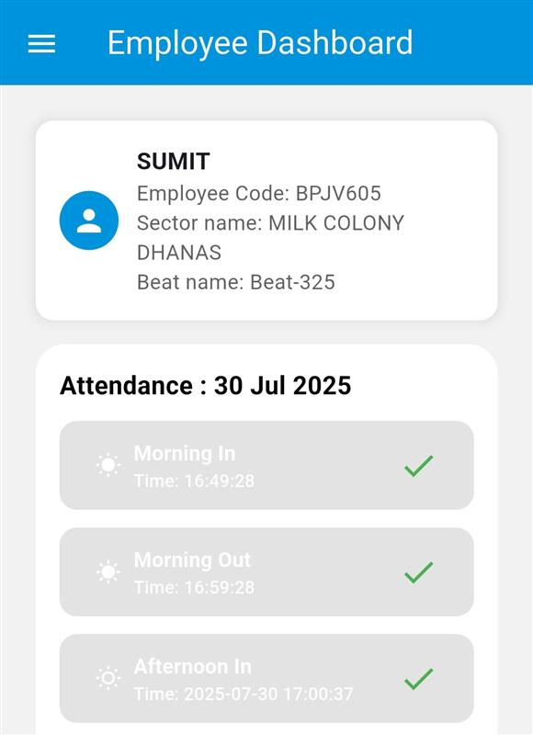

Step 7: Afternoon IN Attendance
- Tap on “Afternoon In”.
- The app captures:
  - Actual Afternoon In Time
  - Face Selfie for verification.

.....................................................................................................................................................................................

Step 8: Afternoon OUT Attendance
- Tap on “Afternoon Out”.
- The system records:
  - Accurate Afternoon Out Time.

......................................................................................................................................................................................

