AG Teams points

1) Coverage Dashboard WPP List- Add Remark & Photo Upload, View Option.
Also, Show in Checkpoint Arrival Report.
REMARK: -Default Option Selection
- Road Block
- Marriage Mandap
- Public Event’s
- Festival
- Water Logging
- Public Vehicle Parked
- Others
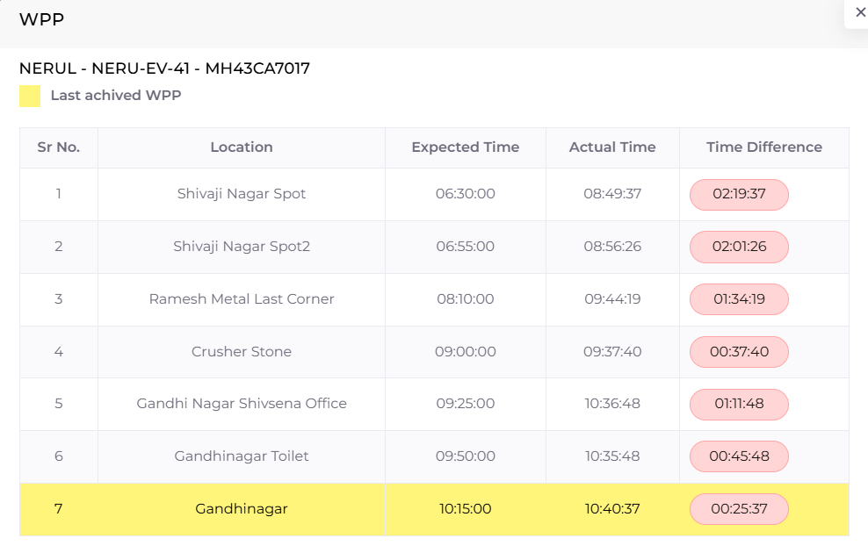

2) Checkpoint arrival report: -
1}Add Reason, View Photo Column.
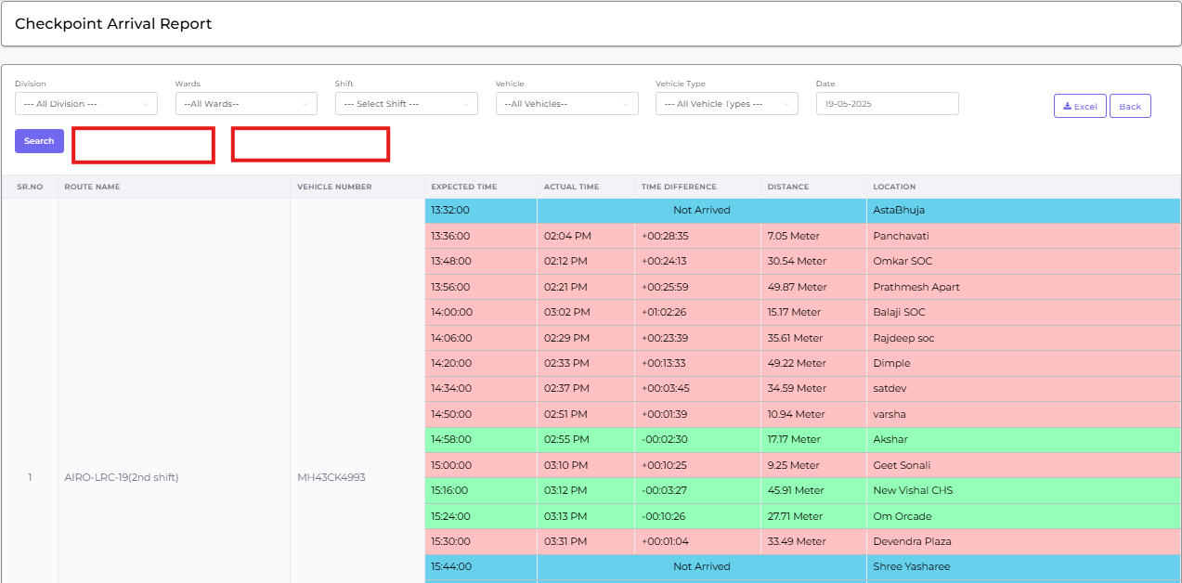
Add
3)Route Performance report: -
1} Add Route number wise Distance KM column
2}Add vehicle Working Hours per route
3) add work end time for vehicle
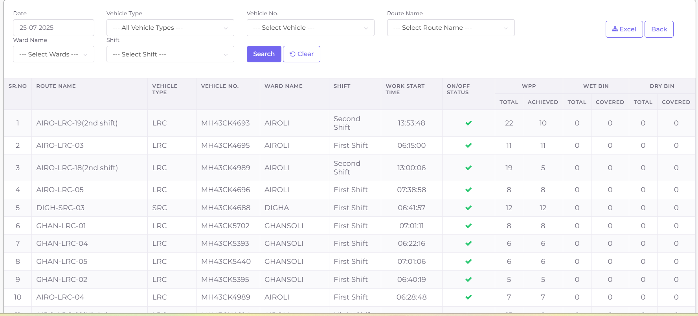

4)Pocket In & Out Time Report: - Vehicle number, Route Number, Pocket IN time, Pocket OUT time.
SR NO. | Division | Ward | Vehicle Number | Route Number | Pocket In Time | Pocket Out Time
1.
2.
3.

5) Stoppage report: - Ward, Vehicle number, Stoppage time, above 15 min Exist WPP.
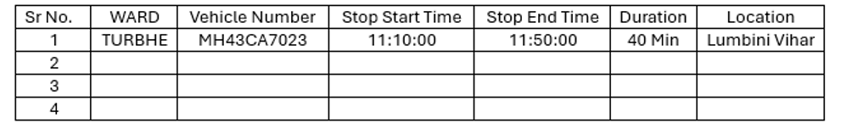
Stop Alert. From the parking exit and apart from wpp if it stops for 15 minutes then adin alert
6) Add time in Dumping Ground Visit Report.
SR NO. | VEHICLE NUMBER | Vehicle Type | TIME | NO OF VISITS
1
2

7) Vehicle Distance report: - Add report Daily, Weekly, Quarterly, Monthly wise, date rage +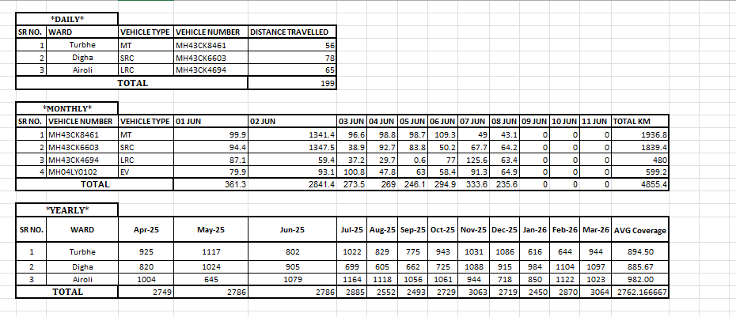

8) Coverage Report Options -Route wise, Vehicle wise, Ward wise, Zone wise.
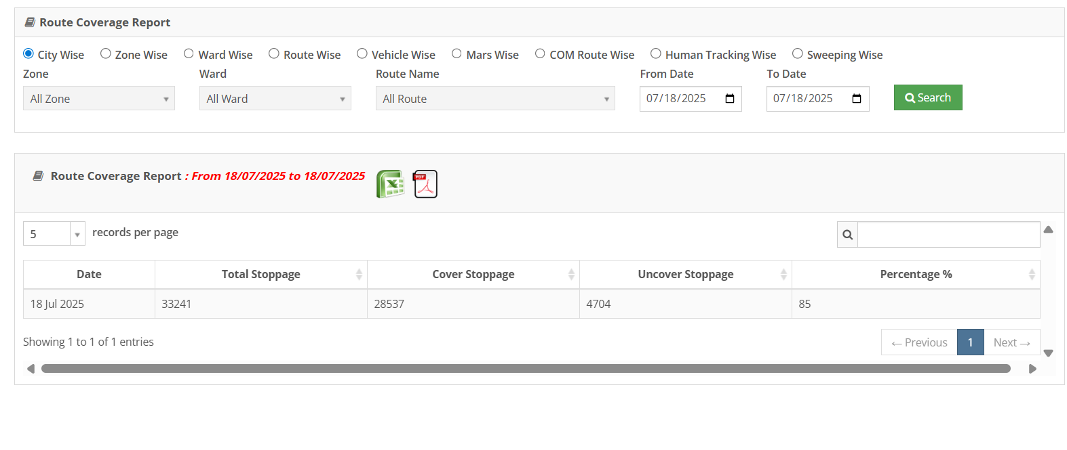 9) Route coverage Report: - Add report Daily, Weekly, Quarterly, Monthly wise, date rage +
10) Route Consolidate report: - Sr no, Ward Name, Vehicle Name, Route Name,
Parking Exit Location, Parking Exit Time, Parking in Location, Parking in Time, Route Start Time, Route End Time, Total Stoppage, Cover stoppage, uncover stoppage, Coverage In percentage, Working Hours, Working KM.
Please find the attached for your reference,
Sr  No | Ward Name | Vehicle Name | Route Name | Parking Exit Location | Parking Exit Time | Parking In Location | Parking In Time | Route Start | Route End | Total Stoppage | Cover Stoppage | UnCover Stoppage | Coverage Percentage | Working Hours | Working KM
1 | TURBHE | MH43CK6286 | TURB-LRC-01 | KK PARKING | 6:32 AM | KK PARKING | 1:10 PM | 6:56:00 AM | 12:20:00 PM | 24 | 22 | 2 | 92% | 6 hrs 38 min 0 sec | 32.18

Uncover Stoppage | Coverage Percentage | Working Hours | Working KM
2 | 92% | 6 hrs 38 min 0 sec | 32.18

11) Vehicle Over speed Notification and Report: - Notification Show on Coverage Dashboard
Vehicle Over Speed Alert Report: - Currently Lat-Long Showing Separately pls combine Hyperlink Lat long.
SR NO. | WARD | ROUTE NAME | VEHICLE NUMBER | SPEED | TIME | LATLONG/LOCATION
1 | Turbhe | TURBHE-EV-42 | MH43CA7023 | 35 | 12:21:00 | 19.0864216 73.0173916
2
3
4
Note: - Vehicle speed limit is 40 they are cross limit above details automatically show in report.
12) Route Deviation Report: -
Same as Nashik report:- For your reference,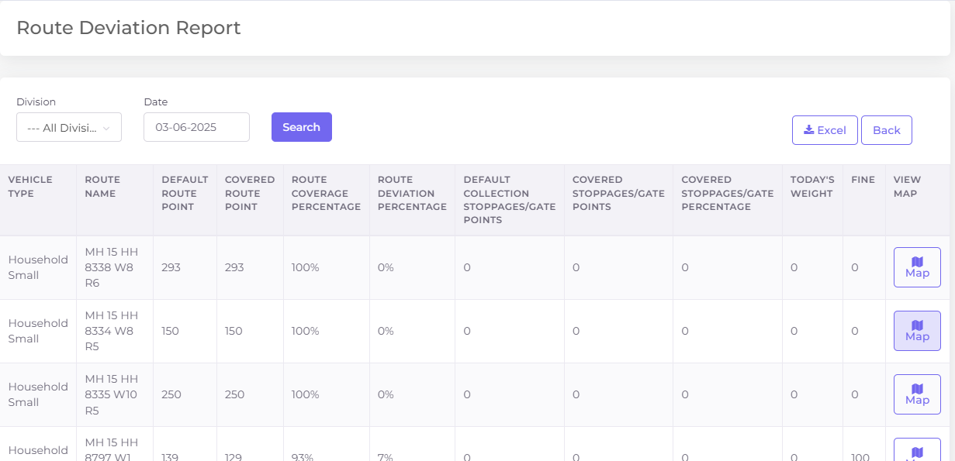

15) Change Home Page Dashboard to NMMC ICCC Dashboard – shift auto select before 2 first shift after 2 second shift and after 8.3 pm third shift – show ICCC menu for other user as well
16) Vehicle Timing status section: - Add List & Report below points- add Parking In/Out Time and work end time.
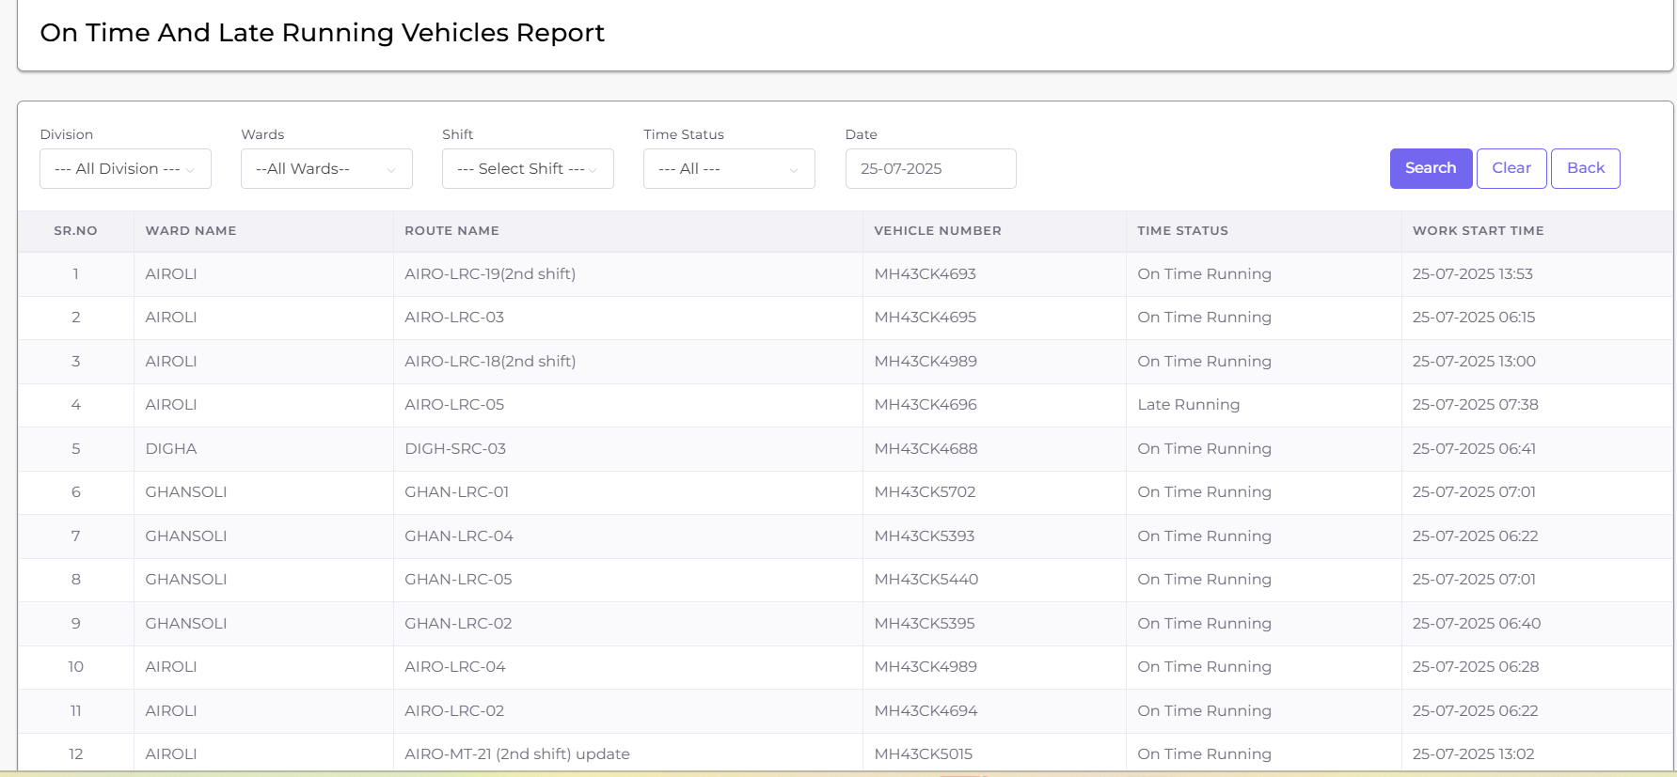

18) OVERALL KM REPORT: - SR NO, PARKING NAME, PARIMANDAL NAME, WARD NAME, VEHICLE NUMBER, VEHICLE TYPE, ROUTE NAME, PARKING TO ROUTE FIRST WPP DURATION (KM), LAST WPP TO DUMPING POINT DISTANCE (KM), POCKET ROUTE LENGTH (KM), DUMPING TO PARKING LENTH, TOTAL WORKING KM, TOTAL WORKING TIME, ACTUAL TONNAGE, DUMPING LOCATION TIME.
SR NO. | PARKING NAME | PARIMANDAL NAME | WARD NAME | VEHICLE NUMBER
1
2
3
4
5
6

VEHICLE TYPE | ROUTE NAME | PARKING TO ROUTE FIRST WPP DURATION (KM) | LAST WPP TO DUMPING POINT DISTANCE (KM) | POCKET ROUTE LENGTH (KM)

DUMPING TO PARKING LENTH | TOTAL WORKING KM | TOTAL WORKING TIME | ACTUAL TONNAGE | DUMPING LOCATION TIME

19. Vehicle GPS active & disconnected (division, ward, vehicle number, vehicle type, Status (GPS active & disconnected).
SR NO. | Division | Ward | Vehicle Number | Vehicle Type | Status
1 | Parimandal-1 | Turbhe | MH43CK0102 | LRC | GPS active
2 | Parimandal-2 | Digha | MH43CK0102 | LRC | GPS Disconnected
3

20. Stand vehicle in parking Alert & details (vehicle number, type, time).
21. Add vehicle status on coverage dashboard- Running, Waiting, Idle, GPS Disconnected.
- Running = Speed > 1 and ignition ON
- Waiting = Speed = 0 and ignition ON
- Idle = Speed = 0 and ignition OFF
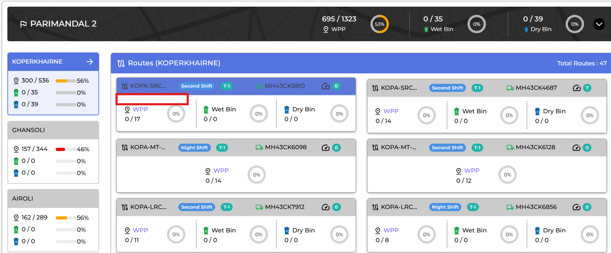
22. Change Below card to Graphs.

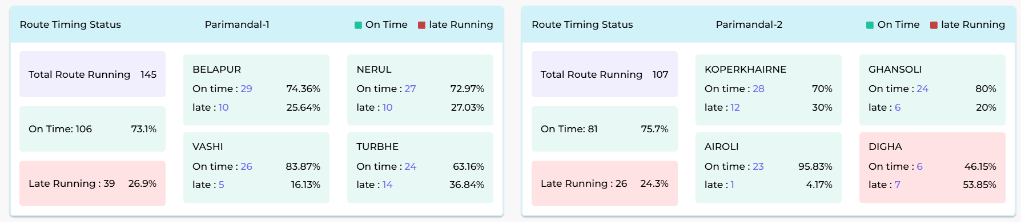

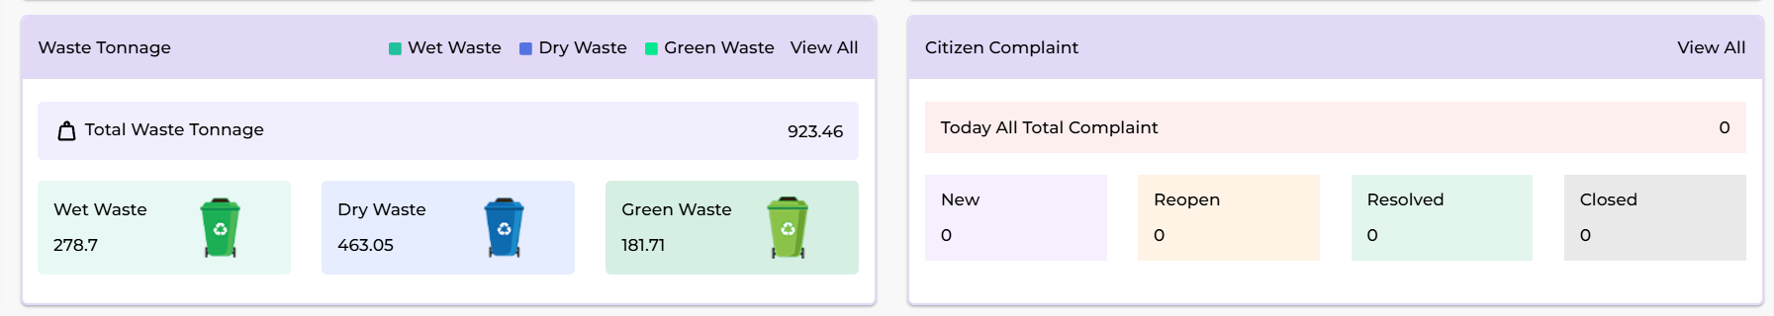

23. Change Bar Color as a Line chart (It’s Look All Blue).

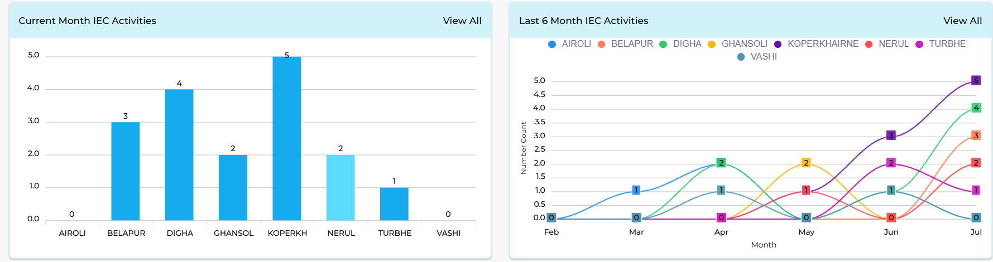

24) Vehicle Running History: - Coverage Dashboard
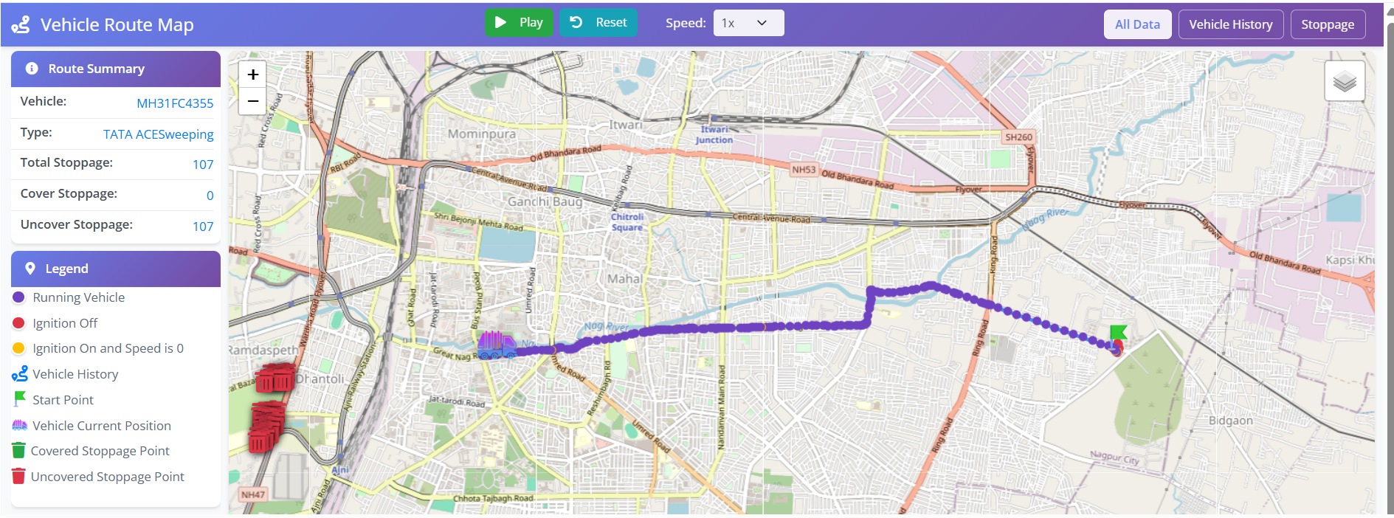
25) Show All Routes: - When we Click on route Hide Route on Map.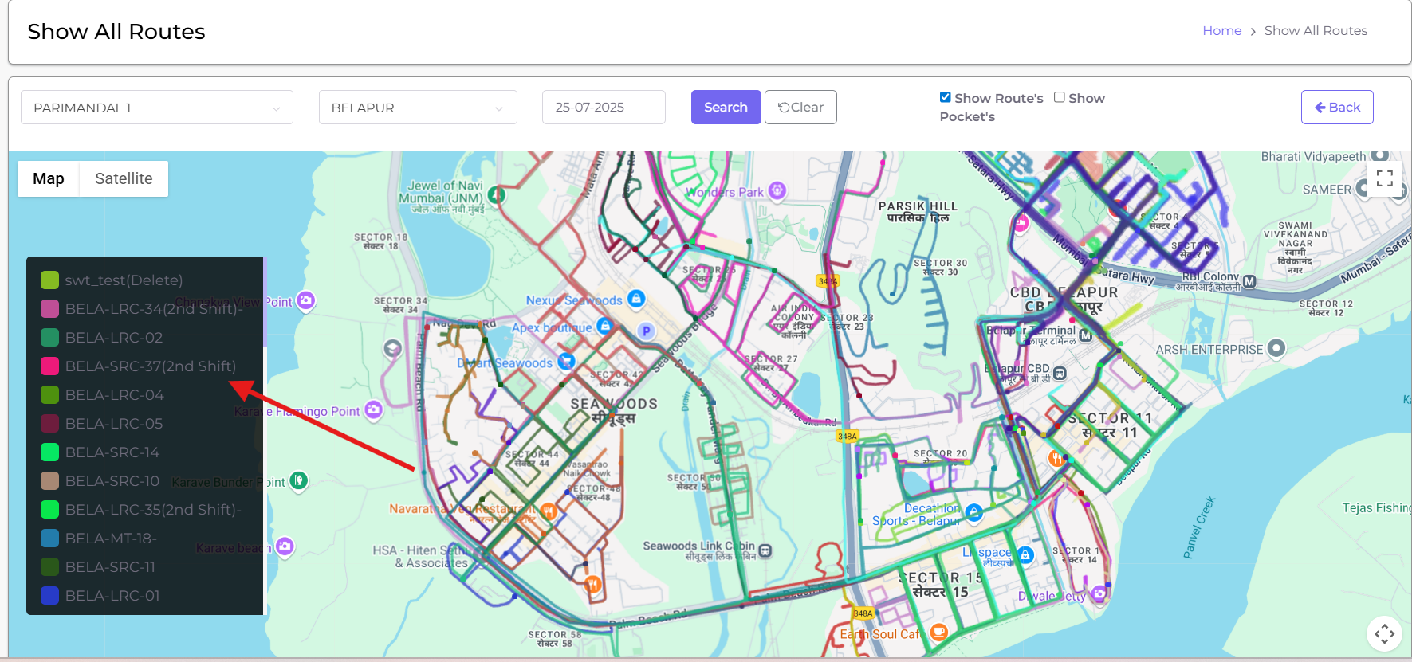

26) Route Hourly Coverage:- Add Zone Wise Details on ICCC Dashboard.

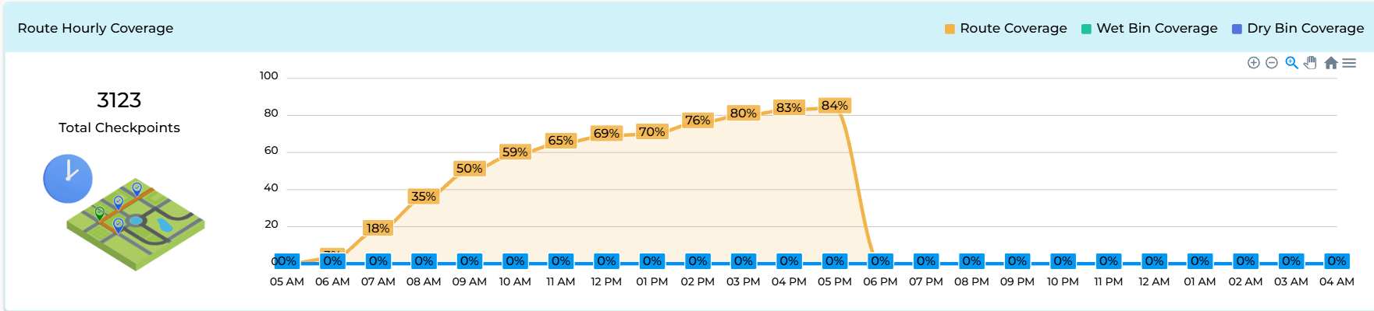
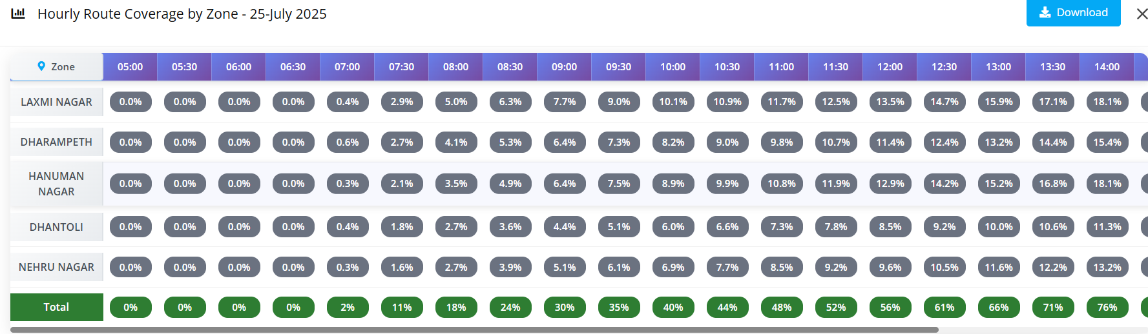
27) Add Toll free Number on ICCC But do not active.
28) All Graphs Transformation Option(Line Chart, Pie Chart, Bar Chart, Column Chart) on ICCC Dashboard.

